- Road repairs starting here on 1st September for four weeks — expect delays  PHẦN ĐỌC BÀI 1 | B. Your journey may take longer on this road in September.
- Dear Guest  Our holiday advisor is available in the lounge every day 8-10 am for booking guided tours, museum/garden tickets, camel rides.  Enjoy your stay’ | A. People staying at Hotel Maroc can arrange activities through the hotel.
- Online Booking Form  Name  Address  No. of tickets  Tickets booked within seven days of a performance are kept for collection. | C. We don’t post tickets booked one week or less before the performance.
- New Message  To: All players  From: Paul  The team is the same as last week - I've already checked everyone can play. Anyone needing a lift to Fyfield can phone me. | A. Players who have a problem getting to the Fyfield match should contact Paul.
- IMPROVED SERVICE:  From next month this bank will remain open until 2 pm on Saturdays | C. The bank will have longer opening hours in future.
- Mum,  The tennis team’s meeting tonight, so I’m taking my tennis clothes for the photo -can’t wait to see myself in it.  Daniel | A Daniel is having his photo taken with the tennis team tonight.
- Casali Restaurant  We are open downstairs while improvements are made to this area. | C. You can only eat in one part of the restaurant at the moment.
- Ann-Marie,  Emma called. She's got a free ticket for this evening's concert as her boyfriend's busy. I've already got one, but if you want to go, call her before 7 pm.  Joe | B. If Ann-Marie is free, she could go to the same concert as Joe tonight.
- ROOM TO RENT -UNEXPECTEDLY  AVAILABLE so only £250 per month including fuel bills  Tel: Erik on 663159 | C. This room is cheap to rent as it was not expected to be empty.
- New Message  From: Maria Gomez  To: Sarah Smith  Please forgive the delay in writing - I’ve been so busy!  I miss your English classes now I’m back in Spain, but at least I can understand everything here! | A. explain why she hasn’t contacted Sarah Smith before.
- THIS DESK IS ONLY FOR THE COLLECTION OF THEATRE TICKETS BOOKED IN ADVANCE | C. You can pick up theatre tickets here that you have already booked.
- Bob,  I tried to make you a dentist's appointment for Friday but they can only do 10 am on Monday. If this OK, ring them before 5 pm today.  Jill  Bob needs to | B. phone the dentist about an appointment.
- IF YOUR SHOES ARE DIRTY, PLEASE REMOVE THEM BEFORE ENTERING THIS CHANGING ROOM | A. You can keep your shoes on in the changing room unless they are dirty.
- MESSAGE  Tony  Maria’s sorry but she’s going to be late this evening. The train is delayed again! Don’t forget you’re meeting her at the station. She should be there at 7.15.  Anita  What is Anita doing? | C. reminding somebody of an arrangement
- INTERNATIONAL STUDENTS’ CLUB  Next Saturday’s coach trip is cancelled because of lack of interest | C. We are cancelling the trip on Saturday as numbers are too low.
- *End of Term Party*  December 15th, 7-10 pm  Sign below if you can come! We also need people to help organise the event - call Sophie (678853) | C. People who can attend this event should put their names on the notice.
- New Message  From: Hintonexiiibrtion5@TCK.co.uk  Subject: Guitar Show  The Guitar Show returns to Hinton Exhibition Centre on 6 March. Many new guitars will be on display. The show is open to schools and the general public.  The main purpose of this email is | C. to provide information about an event.
- Hi Abdul,  I won't be in college as I'm not well. Please call round on your way in to pick up my homework-it's due in today. Thanks, Aziz  Aziz wants Abdul to | A. take his homework to college for him.
- Once opened, remove any unused soup from the tin and place in the refrigerator.  This label gives advice on | A. how to store the product.
- Wanted: Kitchen Assistants  Evenings or weekends  Free meals  Full training provided  Apply inside | B. There are part-time opportunities for people without experience of working in a kitchen.
- Here are the details you requested. We have reserved your hoi day booking until 9 pm tonight, but will require £100 to complete it  If Sally wants to go on the holiday she must | C. pay a deposit this evening.
- Keep your bus ticket. Transport officers may request to see it at any time. | B. There could be ticket checks during your bus journey.
- Peter  The garage called. Your car is ready for collection. The key will be in their office until 5.50. Otherwise bring your spare key and get the other one another time. | A. Even if the garage is closed Peter can pick up his car.
- Paula  Can you give Lewis a ring at his home? I warned him you'd be back late but he said that didn't matter. I'm going out. See you tomorrow.  Jen | B. Lewis doesn’t mind what time Paula calls him at home.
- Hunter Museum closed Re - opens 15 September Entry free Guided tours only Book early  From 15 September museum visitors | A. will have to join a group.
- Ted  On your way home from work tonight, can you pick up some vegetables? J promised I'd make Kate some soup but haven't had time to go shopping.  Thanks!  Liz | B. Liz needs Ted to buy some ingredients for her.
- There are some places available - the orchestra, so if you know people who'd like to join us, why not bring them along to a practice session?  Dan is trying | B. to increase the number of people in the orchestra.
- TAKE ONE OR TWO TABLETS DAILY, IN WATER. THROW AWAY REMAINING MEDICINE AFTER ONE MONTH. | C. You should get rid of any medicine that is left after a month.
- FREE!  PIZZA FROM OUR CAFE WITH EVERY CINEMA TICKET BOUGHT FROM OUR TICKET DESK!  Cinema-goers can | C. get pizza for nothing when they pay to go into the cinema.
- Sarah,  I've left my handbag at the office, so I’m just walking back to get it. Wait for me at the cafe - I won’t be long!  Anna | A Anna is going to be late getting to the cafe.
- Karen,  Your French teacher rang earlier - the Tuesday evening class you wanted next term is full , but Thursday’s available if you can go then instead. He’ll ring back later. Jan | C. Karen needs to decide whether to change the evening that she has classes.
- LOCAL FARMERS SUPPLY ALL THIS SUPERMARKET'S VEGETABLES - KEEPING PRICES LOW FOR OUR CUSTOMERS! | C. We buy our fresh vegetables locally to save you money.
- Jack, My car broke down on the motorway, so I’ll be late picking you up. I’m on the J way again now - see you at your house in 30 minutes.  David | B. David is half an hour away from where Jack lives.
- About that sweater you borrowed for skiing last time - could you bring it round to my place? I'm going snowboarding with Mark soon and it'll be cold! | A. Maria needs Denise to return something she lent her a while ago.
- PARKING  HOSPITAL VISITORS ONLY WAITING LIMITED TO TWO HOURS FOLLOW SIGNS TO STAFF PARKING | C. This car park is for people visiting the hospital for a short time.
- John  I’ve seen an advert for a French restaurant in the town center. Have you eaten there? Would it be suitable for Mum’s birthday on Saturday?  Julie | C. Julie wants John’s advice about a venue for a family celebration
- Olympia Sportswear Further discounts available on certain sale items. Check label for details. | C. Customers can get special prices on some goods.
- Hi  I have to let the theatre know how many tickets are needed. Have you decided yet whether to come with us or not?  Hope so! | A. find out if Bill wants a theatre ticket.
- Matt  Sunday's race starts at 10.00. We can pick up our numbers at registration one hour before. There are no changing facilities so we must arrive ready to run.  Jo | B. Jo is reminding Matt to put on his running kit before he leaves home.
- COMFORTABLE SOFA £20  too large for my new apartment  Buyer must collect  Call Andre: 29B3B4 | B, Andre will sell his sofa as long as it is taken away.
- ONLY BOOKS ALREADY PAID FOR CAN BE TAKEN INTO…BOOKSHOP CAFÉ | - C. Do not taken books which you haven’t bought yet into the café.
- CENTRAL GYM  - 15-minute limit on the use of equiment at busy times | - B. When the gym is crowded, there is a time limit for using the equiment.
- From 3 January the 22 bus….7-10 a.m. only | - C. There will be a limited 22 bus service along Regent Street from 3 January.
- BATON COLLEGE  - TO REDUSE ELECTRICITY COSTS…LEAVING ROOMS | - Save us money by switching off fans when you finish using a room.
- Handie with care- breakable goods inside parcel | - Be careful with this parcel as the goods might break.
- I’m away, but sign here for London trip next Satetday….(coach costs $15)  Kim | C. write your phone number here.
- PHYSICS LABORATORY  Do not enter this room if the red light is on. | A. Only come in if there is no red light showing.
- James  Have bought some sugar for you biscuits…off afterwards!  Mum | B. flour
- LIBRARY CLOSED TODAY  BECAUSE …..LETTERBOX | C. As the library is closed, users can put books through the lettterbox.
- RAIL PASSENGERS WITH TICKETS: PLEASE QUEUE HERE….TRAIN READY | C. Wait here with your tiket until stalf have prepared your train for boading.
- This week’s fitness class will be half an hour earlier, at 6.30 pm, and in the sports hall, not the gym! Next week’s class will be back in the gym at the usual time. | C, The fitness class will be somewhere different this week.
- Tara, we’ve run out of coffee! Can you get some at the supermarket when you’re coming back from college this afternoon? I’ll pay you back tomorrow. Daisy. What should Tara do? | B. go shopping on her way home
- BANK OPENING HOURS Monday – Friday 9 am to 5 pm Saturday 9 am to 11 am The cash machine outside is in use 24 hours | - You can’t go into the bank on Saturday afternoons.
- Max, There’s a problem with the shower. You can’t use it unless you want a cold one! Someone’s coming to fix it this afternoon, so it’ll be OK tomorrow. Mum | B. It isn’t possible to have a hot shower this morning.
- Hi Mia, I might be late for the band practice tonight. I usually get the bus, but there are lots of delays this week. See you later. Henry Question: Why has Henry written the text? | - to warn Mia that he may not be on time
- Lily, Thanks for inviting me to your house next Saturday. I’m afraid I can’t come because I’m going camping this weekend. Maybe we can meet up when I get back? Sara Question: Why has Sara sent an email? | C.to make an apology to Lily
- Music festival 15 August Music includes rock and hip hop Tickets: £6 in advance £8 on the day | C. Tickets are cheaper if you buy them before the festival
- Hi Lucy, The football match starts at 5. I’m getting the bus to the stadium. I’ll meet you there at 4.30. Don’t forget to invite Sam too. Emma Question: What should Lucy do? | B. ask Sam if he wants to come to the football match
- You are invited to a Jungle party on June 21 from 3 pm. Dress up in an animal costume if you want to – a prize for the best one! Food and drink provided. | C. Guests might win something if they wear a costume.
- Marcus Don’t forget we’re going to the cinema this afternoon with James. I’m not sure what film we’re going to see, but we can decide when we get there. Jenna. Question: Why has Jenna left a note for Marcus? | A. to remind him about an arrangement
- Hi George, I’m going camping next weekend, so can I borrow your tent? You bought one last summer, didn’t you? If you’ve got a small cooker, that would be great, too. Thanks. Josh. Question: Why has Josh sent this message? | C.to ask if George will lend him some camping equipment
- To: Photography club members Subject: Picnic Everyone welcome – just meet at the park 2.30 on Saturday. Bring something for the barbecue – drinks provided. Bring your best pictures to share. See you there! Tom Question: What should club members do? | - come to the picnic with food to cook
- Art workshop Saturdays 10.30 – 12.30 From 15 September for 5 weeks Suitable for all abilities | B. You don’t have to be talented to go to the workshops.
- If you enjoy playing the guitar and hanging out making music, contact us, Neil and Joe. No plans to play as a band - we just relax and play! Call 07796 245798 Question: Call this number if you want to | A. play music with others
- Stamp collection for sale Over 12,000 stamps from a range of countries Some antique and rare items On offer as a collection only, not as individual items. | B. Some of the stamps are very unusual.
Part 2
- Sandrine and her ten-year-old daughter, Daisy, love watching all kinds of dancing, especially if the dancers are famous entertainers. Daisy particularly likes the beautiful dresses the women wear. | D. Quicksteps  Each week, well-known faces from the world of television team up with a professional partner to perform a range of classical and modern dances. You, the viewer, can vote for the best performance and the best costume, and each week’s winners will take part in the grand final later in the year.
- Tim has an amazing memory for facts on a range of topics. He enjoys testing himself against people taking part in quizzes on TV and wants to find out how to be on one himself. | E. Taskmaster  Can you beat the four members of the public who answer general knowledge and specialist questions in the final of this year’s competition? Tonight’s specialist subjects include the history of winter sports, Latin American dances, detective novels and French history. There will be information about how to enter next year’s competition.
- Simon enjoys murder mysteries and likes the challenge of working out who did the crime before the identity of the murderer is uncovered in the final scene. | G. Inspector Blake  A first-division football player has a beautiful wife, a big house and a bright future. When he's found dead in his car near a local park, Blake discovers that he was less popular than it seemed. Set in the 1970s, this nail-biting drama will keep you guessing right until the end.
- Mariella loves skiing and enjoys watching winter sports on television. She tries to improve her techniques by copying the professionals who take part in them. | B. Whiteout  All the latest action from the slopes, including men’s and women’s downhill racing, jumping, ice dance and ice hockey. Presented from the mountains by former footballer Neville Gray, with expert reports on speeds and distances. Figure skater Jayne Wilton comments on the dance performances.
- Ned and Jake are computer programmers. They enjoy TV programmes that are funny and give them a complete break from their work, especially if they are connected with football. | C. Top Team  A return of the jokey quiz show, in which teams of famous sports personalities and comedians have to give amusing answers to questions on a range of popular sports, not just football and tennis but winter sports too. Light-hearted entertainment for everyone!
- Tomoko hasn’t skied before and wants inexpensive lessons from a teacher who speaks Japanese or English. She’d like to stay somewhere where she doesn’t have to cook for herself. | C. Ice Mountain  Come to this beautiful spot if you’re new to the sport. Try out easy ski runs under the instruction of qualified teachers - their services are reasonably priced and many speak several languages including English. Classes are for adults only. Guesthouses provide accommodation with breakfast and evening meals. The centre is reached by train.
- Alex and Helen are going skiing for the second time and would like a centre with easy skiing and interesting places to visit. They want to fly there and rent skis cheaply on arrival. | H. Fairview  This historic mountain town has much for visitors to see. The slopes don't attract expert skiers, but are suitable for those wishing to improve their basic skills. English-speaking instructors charge a lot, but hiring equipment is very reasonable. This centre isn't recommended for children. The airport is nearby.
- Matt and Martin are looking for some exciting skiing. They don’t want to be with beginners or worry that there might not be enough snow. They like eating out in the evenings. | A. Windy Pine  The ski and snowboard runs here are high in the mountains so you can be sure of lots of good snow, but they are extremely challenging and only for the expert. Skiers can relax after dark in a number of small bars and restaurants. The airport is a two-hour bus ride away.
- Isabel and her 14-year-old son, Juan, are expert skiers but her husband is a beginner. Juan would like to try other winter sports, like snowboarding. They’ll travel to the holiday centre by train. | F. Rose Valley  This area has much to offer, both to skiers with little or no experience and to those wanting challenging and exciting skiing. Ski instructors speak French and German. Some slopes are reserved for snowboarders. There’s lively nightlife but the weather can be unreliable. Access to the area is by rail.
- Chris and his wife Jo are not keen skiers. They want to be able to relax in the sun and admire the beautiful scenery while their sons of 10 and 12 have skiing lessons. | D. Eagle’s Nest  There’s skiing in this area for skiers of all abilities, with special classes for children, but snowboarders aren’t welcome. Accommodation is in comfortable holiday apartments with balconies, where non-skiers can enjoy the fine weather surrounded by wonderful mountain views. There’s a good bus service from the centre to the nearest train station.
- Susanna only has a couple of hours free. She hates walking and would like to try something that brings her into contact with animals, although she is a bit nervous with them. | E. Park Stables  Have you ever thought of exploring a national park on horseback? Park Stables offers rides on horses specially chosen for their gentle characters. Beginners are welcome and riding hats and boots are provided free of charge. Private ride £25 per hour, family ride £42 per hour.
- Kemal is looking for some excitement and is keen to do something challenging. He also wants to get to know the better. He can afford up to £50. | G. Swallow Aviation  Get a bird's-eye view of the countryside and see some of the region's tourist sights from the air by taking a lesson in a two-seater microlight plane. It's an adventure that's not for the faint-hearted! The training plane is an Icarus C42 which flies at around 160 kph. Flights from £49.
- Frank and Sabine want to go for a walk with their young family. They’d like to have lunch out but Sabine doesn’t like carrying things for the baby, or picnic things, around all day | C. Llama Treks  For something different, let this company’s friendly South American animals accompany you on a walk through the hills. The llamas transport your bags while you enjoy the scenery. The most popular trip is a four-hour walk with a stop at a country restaurant (£55 per adult including meal - children free).
- Charlotte is flying to the Brazilian rainforest soon to do some scientific research. She hopes to get some experience of living in the open air before she goes. | D. Survival School  If you’re thinking of taking a trip to somewhere far from cities and people, you might want to learn how to take care of yourself first. Survival School’s challenging weekend course (£150) will teach you fire-making, camp-building and recognising edible plants and wild animals. These skills could save your life.
- Tom wants to explore the natural beauty of the area in company with other people, doing something other than walking. He doesn't have any equipment of his own but he has £40 to spend. | B. Country Lanes  Based in a lovely forest, Country Lanes provides a relaxing experience for newcomers to cycling, experienced cyclists and those just looking for family fun. The one-day group tour (£30 per person) includes bike hire, route map and discounts on entry to tourist attractions.
- Jake and Maureen have different interests but want to go somewhere they will both enjoy. Jake loves anything to do with the sea, while Maureen’s interested in social history and the lives of women. | F. Fishing Centre  Study the routes used by fishermen over the lost two hundred years and see how their ocean-going boats worked. A new exhibition explores the position of wives and mothers in the old fishing towns, giving information about their occupations, and their attitudes to work and home.
- Melanie is a history teacher. She wants to take her class to a museum where they will be allowed to touch things and have activities to do during their visit. | C. Hillcrest Museum  Enjoy an experience of digging up the past. Handle pieces of ancient pots, tools and other objects from many countries. Learn to date them and see what they tell us about how people lived then. Also try out computer programs which help plan the digging-up of sites. School groups should book in advance.
- Roger is keen to find out about different forms of transport in towns over the last hundred years. He would like to attend a talk while he is at the museum. | H. Horsepower Museum  This museum reminds us just how important horses were to life in the nineteenth and early twentieth centuries. It has a permanent exhibition of old trams and buses, which used to be pulled through the streets by horses. The staff here are very knowledgeable and give daily lectures on this fascinating collection
- Kazuko studies English literature and thinks that seeing where writers lived will help her understand their books better. She finds it useful to look at pictures which are connected with the books. | D. Shandy Hall  Here in the 1760s, Laurence Sterne wrote Tristram Shandy. His fifteenth-century house is now surrounded by a large garden full of beautiful and unusual plants. Inside there is an important collection of Sterne’s novels plus the original drawings which were included in his works.
- Nick is more interested in learning about the countryside than learning about people from the past. He needs information to some schoolwork he is doing about what happens to rivers and hills over time. | B. Castle Museum  The castle was built looking down on the valley of the River Dean. It is now a museum, where you can learn how the valley has changed over millions of years. There is a collection of interesting rocks and fossils found in the area, and pictures showing how the valley probably looked in prehistoric times.
- Nuala and Jaime want to celebrate their anniversary in a stylish hotel with good service. They plan to eat out, see a show and go sightseeing, without using public transport. | B. Mars  Hotel Mars is located on one of the main streets, a short walk from tourist attractions, theatres and restaurants. The luxury rooms are beautifully decorated and furnished with antiques. An excellent breakfast is served by waiters in the top-floor restaurant, which also offers spectacular evening views over the city.
- Sebastian wants to do some exercise at his hotel before attending a conference in the city centre. Afterwards he plans to walk back, have a meal in his room and relax for the evening. | H. Archway  This 19th century hotel is in a busy area with plenty of restaurants, It was modernised two years ago and now has a fitness centre. Rooms are very comfortable with widescreen TV. There’s no restaurant, but you can order decent hot food via reception from the takeaway next door.
- Alex and Mel want a room in a traditional hotel with suitable facilities for their two children. They want to eat well before going sightseeing and want help with ideas for what to do. | D. Haussman  The wonderful city museum is right next door to this friendly 19th century hotel. The old-fashioned furniture end attractive iron balconies all add to the homely atmosphere. The hotel games room will keep all ages entertained, and there’s plenty on offer at the self-service breakfast. Staff are always happy to supply information about what’s on
- Steve wants to stay overnight in a central hotel where he can experience the typical atmosphere of the city. He would like a light breakfast before leaving by public transport for his early morning flight. | E. Windmill  This medium-priced hotel surrounded by artists’ studios, lively bars and interesting food shops is right in the middle of the city. The underground station outside will take you anywhere, including the airport within minutes. Help yourself to breakfast from 8 am downstairs, or coffee and rolls can be brought to your room before that.
- Holly and Lucia are travelling round Europe and want to stay somewhere cheap and with nightlife nearby. They hope to make friends with other young travellers like themselves | G. Hi-Tech  All costs are kept low here. Guests book on the internet, then check in and buy everything (hey need from machines. Breakfast comes in airline-style boxes. You sleep in a tiny cabin for one and roll up your bed during the day. A fun choice for backpackers, who get together m the lively club next door.
- Ken wants to visit a factory where he can discuss guitar-making with people who make them. He'd like to hear music played live, and visit somewhere nearby that’s connected to rock music. | E. PSA  Staff at PSA have made guitars by hand since 1956, and they’ll answer any questions about their work. Visit the factory shop after your tour or watch professional players performing on PSA guitars in die cafe. There’s also the chance to go and see the homes of several rock stars that lived in this area.
- Maria wants to visit a factory that sells low-priced guitars. She'd also like to see some old ones that were played by well-known guitar heroes, and learn how they were created for individual musicians. | B. Ronsons  Ronsons have their own museum full of the guitars they've made for rock stars.  Your guide will tell you about the skills used to make sure that each guitar was exactly what its owner wanted. After the tour, go and visit the Ronsons shop where guitars are available at better discounts than you'll find in other shops.
- Juan wants to learn to make guitars, and would like information on a career doing this. He’d like to see the different production stages, and try playing some instruments. | H. Mitchells  Mitchells train their staff to become as skilled as possible in the art of guitar-making - and encourage people who are considering this as a profession. You’ll get the opportunity to watch exactly how each guitar is put together, and you can even have a go at playing one or two!
- Tomas and Helena want advice on getting a guitar made for their musician son. They want to stay and eat while they’re at the guitar factory, and to buy souvenirs for their grandchildren. | C. Barnards  Barnards are well known for the individual design of their guitars, ideal for professional players with money to spend. You can discuss your needs with staff, who'll make the perfect instrument for you. After your factory tour, relax in the cafe, before visiting the shop which has gifts for every age.
- Sara is studying the history of music, and wants to learn more about how guitars were first designed, and how materials are chosen for them. She’d also like to buy a book about guitar-making. | F. Maxwells  Maxwells have made guitars for over 100 years. In their museum, you can find out about the early development of the guitar, and see how much care still goes into selecting the wood that’s used to create perfect guitars. And don’t forget the gift shop, with its huge selection of books on the guitar.
- Victor and Olga need a personal instructor to teach them better powerboat skills, and to find their way safely around the waters oft the coast. They want to go without booking in advance. | D. Marston Centre  The Marston Centre offers courses at all levels for learning to manage every kind of boat you can think of. Fees for private teaching sessions are reasonable, and it isn’t essential to arrange this before you go. The centre also offers training in how not to get lost at sea. See their website!
- Felipe wants a weekend training session for his staff, to help them work well together. He'd like them to do sailing and indocr activities, and have comfortable overnight accommodation at the centre. | H. Aqua Sports  Aqua Sports offers company team-building courses that can include water sports on the lake or a range of things to do in the gym. You can select the perfect timetable for your team. Afterwards, you can have a good night’s sleep in the Centre’s excellent hotel.
- Harry wants to find a centre where top people in watersports train and where he can measure his skills to see if he could compete professionally. However, he can’t afford anything too expensive. | E. Padcaster Centre  The huge lake at the Padcaster Centre is perfect for waterskiing and sailing. It’s regularly used by sportspeople preparing for the Olympics, and has a cycle path around the outside for your coach to accompany you on land and check your speed. See how you compare with the champions! Prices are very fair.
- Tania and Paolo can already waterski, and want to try another challenging watersport. They want to go in the evenings, and be able to eat at the centre afterwards. | B. Marinewater  The Marinewater website shows their whole range of watersports from sailing to the exciting experience of controlling a boat on a fast-moving river. The route is used by professional athletes in training, so it is lit until late, while the Centre’s restaurant serves delicious meals. Booking is recommended.
- Laura and Adam want to celebrate Laura’s birthday at a waterspc centre with friends, some of whom prefer to do indoor sports.  They’d like to have a good idea of what the place is like before going. | F. Camford Centre  The Camford Centre offers sailing for people who love relaxing on the water, and also has volleyball and badminton courts in its well-designed building. Check out their website - their 360-degree video tours show you exactly what's available. And if you're coming for a special occasion, tell us - we'll prepare a fantastic meal in our restaurant!
- Yang is looking for used copies of modern novels for her book group. She would like to visit a bookshop where her two young daughters will be welcome, with drinks and snacks available. | G. Holt’s  Although its prices arc high, the fun of Holt’s is its lively atmosphere. It’s in an old railway station, where you can enjoy afternoon tea and cake in the waiting room. Or leave the kids to play in the former ticket office while you look at the huge selection of recent fiction.
- Stefan loves beautiful art books but would like to check what’s available on the Internet before visiting. He wants to find a bookshop where he can get lunch and spend the afternoon looking at books. | E. Scrimshaw’s  Scrimshaw’s has a huge selection of books showing the works of the great painters. Most are in excellent condition and reasonably priced, and the store’s online guide is regularly updated. The basement also has a cafe and -a large number of out-of-date school textbooks on sale.
- Scott has been unable to get a particular textbook which he needs urgently for his project on health care for the elderly. He is very busy and would prefer to have it delivered. | F. Regal  Here you’ll find the country’s largest selection of science-related books, including topics such as psycholog)' and medicine. There are 70,000 used and new books, all at discount prices. Regal also has an efficient online ordering service plus comfortable sofas and freshly made coffee, and is open during office hours.
- Jasmin is setting up a library of classic fiction for her primary school. Before buying some books online, she would like to go to the shop and discuss suitable books with staff. | D. Topping's  You'll only find good-quality used hardback books here on certain subjects. Topping's is run by three experts in art, travel and literature for the young. They are happy to chat and advise customers. The shelves are well-organised, and books can also be ordered from the shop's website.
- Ian wants a quiet bookshop where he can relax in comfort with a coffee for a few hours after a long day at work. He’d like to get a few cheap novels to take home. | B. Bales  This shop is famous for its range of titles, from college textbooks to classic literature, and is known for its peaceful atmosphere. Regular customers come for the excellent cafe with its sofas and armchairs, which stays open until late.
- Philip and Jenny have to children who cannot swim... play safely in the water....to park near the beach. | H. Marple  Although unsuitable… Swimming is good… water are safe for children…next to the beach… the car park.
- Marco and Sandra want to spend …beach and have lunch in a café…to go surfing,…relax in the sun. | D. Torsands  A very sheltered beach…sunbathing… surfing and sailing… café and a children’s… ten-miute walk across fields.
- Remi Claudia want to relax on the beach… some sport,… buy some presents to take home. | F. Halcombe  This is a small beach… many shop… Golf Club,… not permitted.
- Richard, Fiona and their seven-year-old… swim and go for a walk…. A children’s play are, …to buy souvenirs. | A. Hadwid  A sandy beach… swimming..children’s play area,.. small shop… walks along the coastal path.
- Paul and Rachel want somewhere with lot of space… enjoy the view… eat lunch in a café. | C. Amrith  A large beach… pleasant views out… there is a café … but not shop.
- Chloe enjoys team sports but doesn’t want to play in competitions. She needs a morning class. She doesn’t have much money and can’t afford to buy expensive equipment. | C. Active plus! This is a great class for people who enjoy playing sport with others in an informal way. Choose from a range of sports, including 5-a-side football and hockey. Classes are on Saturdays from 9–11 am. We provide balls, hockey sticks, etc. and a monthly report on how your fitness is improving.
- Mike isn’t very fit. He would like to get fitter, but he finds exercise boring. He’s looking for an evening class that is different every week. He’d also like to see how he is improving over time. | D. Water-cise! Have fun and get fit at your local sports centre! Classes every Tuesday and Thursday from 6–8 pm. No two classes are the same! We organise regular competitions and also offer individual fitness checks every month, plus the chance to gain progress certificates.
- Sofia loves sport but is recovering from a serious injury. She wants to train in the afternoon with someone who understands her injury and can give her advice on exercises she can do at home. | E. Fitness for All If you’re looking for a gentle, low-cost exercise class, Fitness for All offers exercises to improve your strength and confidence slowly. Our trainers are qualified to help with individual problems and can give you extra ideas to try outside the class. No equipment necessary. Classes: every Tuesday from 2–4 pm.
- Jack is very fit and is planning a challenging 200km run. He wants to train at least twice a week and would like some personal training too. He wants to train indoors and outdoors. | G. Rising stars We believe sports are for winners! We offer training from professional sports coaches to help you become a more successful player. Choose from a range of team and racket sports. Players are encouraged to join local and national leagues. Classes: every Saturday and Sunday, or book an individual lesson with one of our trainers.
- Tara takes sport seriously. She plays hockey and tennis and wants to improve her skills and take part in compertitions. She isn’t free from Monday to Friday. | H. Go for it! This is a class for people who want to push themselves so they can compete against other people or themselves! Training takes place every Tuesday, Thursday and Saturday. Classes involve a one-hour run in the park, followed by weight training in the gym. Individual coaching and advice on improving fitness at home are also available.
- Emma loves using her imagination in a creative way. She loves working on projects with other people, and she would like to visit places and see creative people at work | F. Action! We are a film club, but we don’t watch films – we make them! We’re always looking for new people with interesting ideas. You will do activities in small groups, so it’s a great way to learn new skills and make friends. We also organise regular trips to film studios to see how the professionals do things.
- Marco loves making things, and he enjoys meeting people from other cultures. He would like to learn a skill that he can use outside the class | G. A world of food We can teach you to prepare delicious dishes! Our trainers come from five countries, and they love to share their recipes and the history of their cultures. This class will teach you how to create wonderful food in your own kitchen. You never know, you might decide to become a professional chef one day!
- Amina is interested in serious issues. She enjoys listening to talks and learning about life in other countries. She would also like to discuss her ideas and opinions with other people | A. Think! Do you want to know more about international events? We meet once a week for an informal discussion. Each week we watch a film from around the world and/or invite speakers to help us understand recent events. At our next meeting we are showing a film about earthquake rescue teams.
- Niko enjoys going to different places and meeting people from different backgrounds. He’s also keen to find out about the place where he lives. He’s especially interested in history | H. City explorers Get out and about with City explorers! We explore our own city and produce information guides so that visitors can enjoy it, too. We also produce maps of the city, past and present, showing how it’s changed. We often get together with groups from other towns and cities to compare information and experiences.
- Erica is keen to help other people. She enjoys events where there are crowds of people. She wants to learn skills she can use in a job when she finishes her studies. | C. Party Plus At Party Plus, we are looking for new people to help. We organise street parties and concerts to raise money for local charities. It’s challenging work, and you have to work with a wide range of people, but you’ll have a lot to offer future employers, and you’ll make a difference!
- George wants a holiday with a big group of friends. They are into sports and want to do different things every day. He doesn’t like boats, and some in the group have young children | G. Active fun Looking for an active holiday? This wonderful busy holiday resort offers tennis, swimming, golf and lots more. There’s something for everyone. Lessons are available so you can learn something new, whether you’re 5 years old or 55! Fun for all the family! Price includes accommodation and breakfast.
- Ana loves to be near the sea. She wants to visit different places, but she also wants to keep away from holiday resorts. She enjoys being active and learning new skills. | E. Seaview Hotel Enjoy a week at this wonderful, small, luxury hotel in Spain. The price includes all food and drinks, and the facilities include a swimming pool, tennis courts and a restaurant. We organise trips to plays and concerts in the evenings. There’s also a beach where you can sit quietly and relax or read!
- Harry just wants to relax and have fun by the sea. He loves going out and wants to meet other people. He wants a cheap hotel and would prefer to pay for everything together. | A. Golden Sands Beach Club There’s lots to do at the Golden Sands Beach Club in Mallorca. It’s a holiday you can afford. Enjoy wonderful beaches and swimming in the Mediterranean or take trips to nearby villages! Then enjoy shows and make friends at the social activities in the evening. All meals and drinks are included in the price!
- Jess wants to travel abroad and learn about a different way of life. She wants to stay with local people, not in hotels. She would also like to see some performances. | D. Culture shock Get away from the usual tourist destinations and visit India. On this tour, you’ll visit seven cities, see the famous Taj Mahal and enjoy time at a beach resort. You’ll stay with families and experience daily life with them. A full programme of cultural events includes some amazing dance shows!
- Greg doesn’t like crowded beaches and wants a peaceful holiday where there aren’t many people. He enjoys walking in the countryside and is happy to spend some time alone with a good book. | C. Forest Camp Get away from it all at Welldale Forest. Stay on a local working farm or in cabins in the forest. Join in farm life or explore the many paths through the forest with our friendly guides. For those who prefer to relax, you can just enjoy time on your own listening to the sounds of the forest.

Part 3
Lost in the Rocky Mountains
11. Bob Rigsby was in Canada in order to study its wildlife. B
12. On the first day of getting lost, Bob realised how serious his situation was. B
13. Bob had few problems finding something safe to eat in the mountains. A
14. On the fourth day, Bob recognised the place that he was in. A
15. Shirley thought that Bob sounded upset on the phone. B
16. It was the first time Bob had been missing for such a length of time. A
17. The first phone call that Shirley made was to the Canadian embassy. A
18. The hotel owner was worried while Bob was absent from the hotel. B
19. Employees from the hotel went to look for Bob. B
20. Bob says he regrets going into the mountains on his own. A
Young People’s Music Day
11. The aim of the music day is for young professional musicians to meet each other. B
12. Students will learn some music to play to an audience in the evening. A
13. At the concert, the professional musicians will perform individually. A
14. Transport home by coach from the concert hall will be provided. B
15. Classes will begin straight after the students have registered. B
16. Each student attending may be lucky enough to be taught individually. A
17. Students wanting any of the goods on sale can collect their chosen items after the concert. B
18. Students staying to wait for the evening concert are advised to take their own entertainment. A
19. Some students will need to bring their evening clothes with them in the morning. A
20. For safety reasons, the organisers want to know how many students will be at the concert. B
Climbing mountains
11. Gertrude Benham had spent less time climbing in Canada than Charles Fay. A
12. Charles Fay applied to an organisation to have a mountain named after him. B
13. On 19 July, Gertrude Benham found out she had made a mistake. A
14. Gertrude Benham decided to climb Mount Heejee with Charles Fay on 20 July. B
15. Charles Fay blamed his guide when he failed to reach the top of Mount Heejee. A
16. Gertrude Benham took a different route up Mount Heejee from Charles Fay. A
17. Gertrude Benham knew Hans Kaufmann had a plan to choose a slow route up Mount Heejee. B
18. The mountain which was named after Charles Fay was the one he had first chosen. A
19. Charles Fay’s grandson followed a different route from his grandfather up Mount Fay. A
20. The hut named after Charles Fay is still used by climbers. B
John Chapman
11. In 1440, John Chapman lived in Norwich. B
12. John rarely managed to sell all his goods at the market. A
13. John and his wife had enough money to live comfortably. B
14. John’s wife encouraged him to make the journey to London. B
15. People stopped to chat to John while he was standing on London Bridge. A
16. John was disappointed by what the old man told him. B
17. John’s wife realised why he was digging a hole under the tree. B
18. The writing on the box was in a language that was foreign to John. A
19. The second container was buried directly under the first. A
20. The people of Swaffham benefited from John’s good luck. A
The Glen Nevis River Race
11. Visitors come to Glen Nevis to enjoy outdoor activities all year round. A
12. Parts of the course of the River Race are less rough than others. A
13. Competitors are able to begin the race as soon as they are ready. B
14. The depth of the water has an effect on how long the races last. A
15. Some people return to do the race again and again. A
16. Only certain types of lilo may be used in the race. B
17. Competitors must use the safety clothing provided by race organisers. B
18. The most frightening part of the race is in the second halt of the course. A
19. Members of the mountain rescue team are paid professionals. B
20. There is a fixed charge for visitors who come to see the race. B
Tracker Star-Watching Centre
11. The Tracker Star-Watching Centre is right at the top of a mountain. B
12. There is a variety of ticket prices that you can choose from. B
13. You can attend various courses at the Centre during the day. A
14. You are allowed to use the Centre’s special equipment by your self to see the stars. B
15. Centre employees will help you to notice the best sights in the sky. A
16. Visitors will get different views of the planet Saturn, depending on when they visit. A
17. A telescope is needed to see all the objects that the staff show you. B
18. Some students from a nearby university can answer the questions you have. A
19. You can buy something to wear at the Centre if you feel too cold. A
20. Visitors who need fuel for their vehicles can get some on the way up the mountain. B

My first long motorbiking trip - by Graham Jones
11. Graham says his friend Luke was keen for him to enjoy riding motorbikes. A
12. Luke was confident their first ride with his club would be a totally positive experience. B
13. For Graham’s first group ride, they planned to go to a place 100 kilometres away. B
14. One rider in their group, Tania, started her bike without help when it broke down. B
15. Graham wondered if he would feel the same as Tania if his bike had the same problem. A
16. At one point, the group leader decided to change the route they were following. A
17. Luke was concerned that the weather conditions were making their ride dangerous. A
18. They found that the clothes they were wearing protected them from the weather. B
19. Luke and Graham’s mood improved after they reached Graham’s house. A
20. Immediately after the trip Graham bought a new motorbike of his own. B
Arctic expedition
11. A building was ready for the scientists to work in on their arrival in northern Canada. B
12. This was the first time scientists had tested Arctic sea water during the winter months. A
13. Information was collected on the expedition to help explain the reasons for climate change. B
14. The North Pole was the destination of a previous expedition that Ann had been on. A
15. Ann had to do special training to be strong enough for the expedition. A
16. During her career, Ann has discovered ways to deal with feeling cold. B
17. Ann's group achieved everything they had aimed to do. A
18. Helen knew it would be difficult doing experiments in freezing conditions. A
19. When she went onto the ice, Helen carried equipment to prevent wild animals from attacking. B
20. The expedition research is now available for other scientists to read. A
Football stars at school
9. Ashton-on-Mersey School is very close to Manchester United’s football ground. B
10. Young players join Manchester United from many different countries. A
11. Some young players start playing for the main team when they are 16 years old. A
12. Most young players go on to become professional footballers. B
13. Some football clubs allow their young players to stop studying. B
14. At Manchester United, young players have some experience of normal teenage life. A
15. Manchester United’s young players have classes at school every day. B
16. The MU students don’t have to follow all the shool rules. B
17. The main advantage for the shool is that it receives money from the football club. B
18. One player helped some students to speak French better. A

Could a personal shopper help you?
9. Adlers’ Department Store has just started offering a personal shopping service. B
10. The personal shopping charge is refunded if you buy some clothes. A
11. The personal shopper starts by showing you some clothes to find out what you are looking for. B
12. Personal shoppers learn their skills from people who know the job well. A
13. You should decide how much you can afford to spend before you come to your appointment. A
14. You have to share a changing room with other shoppers. B
15. A maximum of five people can attend an appointment together. B
16. The personal shopper can help you to find clothes at reduced prices. A
17. You have to book in advance to get an appointment with a personal shopper. B
18. With the special offer this month, you can only save money on electronic goods. B
Bees, bees, bees
9. Lisa first saw the bees in her garden when she opened the window. B
10. Lisa went back into the kitchen because she heard the bees. A
11. Lisa was scared when she saw the bees. B
12. The beekeeper thought it was funny that the bees had landed on Lisa’s cake. A
13. Even though the bees had eaten a lot of the cake, Lisa still ate it. B
14. When John saw the insects, he knew immediately that they were bees. B
15. John stopped his car because he wanted to call a beekeeper. B
16. The queen bee was in the boot of John’s car A
17. The bees followed the car because they could see the queen B
18. John got out of his car when the beekeeper arrived B

Open-air Theatre
Part 4
21. What is the writer trying to do in the text?
C. explain what it’s like to work in an open-air theatre
22. When plays are disturbed by local wildlife, the actors
A. change their performance to include it.
23. What is the audience’s attitude to bad weather during performances?
C. They accept it as they have come well-prepared.
24. What does John Barnack say about outdoor theatre?
B. He’s happy that the audience feel comfortable being there.
25. What would an actor from the Coastline company write in his or her diary?
D. I’m keeping a tradition going, and it tests my acting skills, as I never know what unexpected things I’ll have to deal with...
Rik Mayall talks about his experiences as an actor
21 What is Rik Mayall’s main purpose in writing the text?
C. to talk about his favourite acting roles
22 What does Rik Mayall say about The New Statesman?
B. Not everyone approved of it.
23. What kind of work does Rik Mayall prefer?
A. performing in front of an audience
24 Why was Rik Mayall pleased about acting in A Family Affair?
B. The writers of the play admired his performance.
25 Which of the following is the best description of Rik Mayall?
D. He is a successful actor who says that he enjoys playing characters who are unpleasant.
At home in Venice by Francesco da Mosto
21. What is the writer’s main reason for writing this text?
C. to say what he feels about his birthplace.
22. The family who first owned the writer’s home
A. used to buy and sell silk.
23. What does the writer say about his grandfather?
C. He wasn’t able to get to know his grandfather personally
24. What is the writer’s attitude to Venice today?
D. He thinks local businesses should be encouraged to stay.
25. What might the writer say about his house?
B. My house is on a canal in Venice and my family, starting with my grandfather, have lived there since 1919.
Anna Gomez
21. What is the writer doing in the text?
C. describing the progress of Anna’s professional life in sport
22. What do we learn about Anna’s time at university?
C. She managed to get good results
23. Why does Anna believe she failed to win competitions as a teenager?
B. She was not confident enough in her ability
24. What does Anna say about her retirement from skating?
A. She has no regrets about giving up when she did.
25. Which of the following appeared on a website about Anna?
D. After five years at the top, ice-skating star Anna Gomez returns and takes up a new job in television.
Cliff Jones
21.What is the writer trying to do in this text?
B. explain a rather unusual choice of transport
22. What made Cliff realise he wanted to cycle round Britain?
D. taking his bike to another country
23. When Cliff met other cyclists in the mountains, he was
B. satisfied with his own type of bicycle.
24. What was Cliff’s biggest problem during the trip?
A. He fell ill for nearly a week.
25. What might Cliff say after his trip?
C. I was happy when I managed to get started at the second attempt. Fortunately, my knee didn’t give me any more trouble.
James Waltham - Chocolate Taster
21. What is James Waltham doing in the text?
C. telling readers what makes his job worth doing for him
22. James says that when he tells people about his work, they
B. doubt whether he is serious.
23. James says that working in his kitchen involves
A. trying various different preparation methods.
24. What does James think is a disadvantage of his job?
D. He needs to travel abroad some of the time.
25. Which one would be an advert for the chocolate company James works for?
D. We check everything that goes into our chocolate, so that you can enjoy the best chocolate possible.
American Black Ducks by Sam Prentice, wildlife biologist
21. What is Sam Prentice doing in the text?
B. explaining how he is doing a piece of research
22. What is Sam hoping to discover about American black ducks?
A. what their behaviour is like after dark
23. When Sam spends long periods watching ducks, he
D. sometimes finds it difficult to stay awake.
24. What does Sam say about working inside a lab over the summer?
B. He accepts that it's a necessary part of his job.
25. What might Sam say about his experiences of working outdoors?
C. Sometimes the moon hasn’t been very bright, but our equipment provides the amount of light we need to collect information.
Helen Skelton
21. What is the writer doing in this text?
C. describing a woman's achievement
22. Helen knew she would be safe if she fell because
C. she was wearing special equipment.
23. During her training, Helen was surprised to find that
B. she had to work so hard at her fitness.
24. When Helen performed her work on the high wire
D. she managed to keep herself calm.
25. What might Helen say about the walk?
D. The training could be painful at times but at least I’m in really good condition now, ready for my next challenge.
A hotel under the sea
16. What is the writer doing in this text?
C. giving information about an underwater hotel
17. What do we learn about the hotel?
C. It will only have a small number of rooms.
18. What can guests do in the hotel?
B. watch the ocean life near the hotel
19. What is the best thing about the hotel, according to the designers?
C. It won’t cause any damage to the environment.
20. What might a guest in this hotel say?
B. It’s great to stay in such a beautiful hotel that is also good for the planet.
The price of a perfect holiday?
16. The purpose of the text is to
C. explain some of the problems that cruise ships cause.
17. One reason cruise ships cause a lot of air pollution is because
D. they use types of fuel that are not permitted on land.
18. What do we learn about the waste products on cruise ships?
D. An enormous amount of the waste water isn’t recycled.
19. Why are cruise ship passengers not popular in some cities?
B. They don’t spend money on meals.
20. Which best describes large cruise ships?
A. They seem to offer ideal relaxing holidays, but they aren’t environmentally friendly.
Athletics in Jamaica
16. What is the writer doing in this text?
D. discussing the importance of an athletics championship
17. What does the text say about the Championships?
C. They started over 100 years ago.
18. What does Dwayne Simpson say about the Championships?
C. They encourage young athletes to do their best.
19. According to Nathaniel Day, the event
A. helps young athletes get used to being filmed.
20. Which best describes the Jamaica Schools Championships?
B. It’s an important event which helps young athletes to improve.

Part 5
Alexander Graham Bell
Alexander Graham Bell was born in Scotland in 1847. His father, an expert on speech, developed a way of teaching how words should be pronounced. He translated the sounds of words into straight or curvy lines.
Alexander trained to be a teacher and, when his mother went deaf, he started to be interested in how deaf people communicate. In 1870, because his children were in poor health, Alexander and his family moved to the United States. He hoped that a warmer climate would be better for the whole family.
It was while he was teaching deaf children there that he invented a new machine. It was very similar to the human ear itself, and Bell discovered it could carry human speech along a wire from one place to another. It was not long before the telephone was a part of every our lives!
THE ART OF DRAWING
Drawing has always been a very popular hobby. Young children draw with a pencil as soon as they can hold one. Drawing is often seen as a special skill, and it is true that some people seem to draw perfect pictures without any effort. Yet drawing, like writing, can be learnt; you can draw accurately if you work really hard at it.
Drawing is first of all about looking carefully. It sounds easy to say that all you need to do is look at things, but it really is that simple. The best way to draw a familiar subject is to imagine that you are looking at it for the first time
Nowadays there are more courses and materials available than ever before which means that you can experiment to improve your skills. The only limit is your imagination.

Cave Paintings in Australia
A cave containing over 200 paintings was discovered in the Wollemi National Park, Australia, eight years ago. Some of the paintings are at least 3,000 years old.
What is even more surprising is that the cave was found by chance by someone walking in the area. However, the site of the cave was so difficult to reach that it took a long time before researchers could visit it.
The exact location of the site has to be kept secret. This is to prevent the cave from being visited by sightseers who do not realise how easy it is to damage the paintings.
The paintings show people and animals, including birds, lizards and other Australian
animals that can still be seen today. According to researchers, until its recent discovery, nobody had visited the cave for around 200 years.
The Driest Place on Earth
The Atacama Desert in Chile is known as the driest place on Earth. It is almost 1,000 kilometres in length, lying between the Pacific
Ocean and the Andes mountains. Under a centimetre of rain falls annually, and the centre is so dry that scientists have never recorded any rain there.
Over a million people actually live in the Atacama today. Most live on the coast, which is also home to teams of astronomers who are there to take advantage of the clear skies. In the north, farmers grow tomatoes with water they have collected from underground rocks. However, for those who have their farms on higher ground, the water comes from melting snow.
People generally seem to lack knowledge about what the desert has to offer, but in fact, there is plenty to do - from seeing the amazing natural sights to playing golf, one of the more recent activities attracting tourists to the region.

Alpacas
Alpacas were first kept by the Inca people in the mountains of South America, more than six thousand years ago. These animals provided clothes, food and fuel for their owners. The softest wool was mainly worn by the leaders of Incan society though. When Spanish explorers arrived in the fifteenth century, sheep were introduced and these gradually replaced alpacas in the region. It wasn't until the middle of the 20th century that both farmers and fashion designers began to recognise the qualities of alpacas again. They are easy to look after since they eat grass and are used to low temperatures. Their wool, which comes in a range of natural colours from white to dark brown, is lighter and warmer than sheep's wool and instead strong.
It is not surprising therefore that alpacas are becoming a familiar sight in
the fields of North America, Australia and the UK.
Horses
Horses have been valuable to humans for thousands of years. Because there are several different sorts of horses such as coldbloods, which are large but gentle, or hotbloods that are known for their running ability, there are horses for every purpose. We use them for transport as well as for physical work, for example pulling farm machinery. It's now also very common to see horses used in sports.
Horses need food and water in large amounts. A horse can drink between twenty and forty litres of water a day, and around a kilo of food for every fifty kilos of its body weight. Horses need to be out in the fields, as grass is part of their diet.
They can live for over 25 years, so their owners need to give them plenty of love and attention - but horses always give lots back.

Wool
Wool comes from sheep and certain other animals like goats and rabbits.
Over a million tonnes of wool is produced every year, of which 60% goes
into clothes. The wool that is used mostly comes from Australian Merino
sheep. Their wool is good for baby clothes, as it is soft. Keeps babies
warm, and can protect their bodies.
When wool is first cut from the sheep, it contains a high level of a valuable
oil, so before the wool is used, it must be cleaned. The simplest way to do
this is by putting the wool in warm water. The oil that is removed from the
wool is widely used in products like hand creams.
Sheep were first used by humans several thousand years ago, but it is believed that this was for meat rather than wool. When people
developed a way of cutting the wool from sheep it became a more important material.
Finding Gold
Most people would agree that finding the perfect ring for your partner is difficult. However, John Greenwood, a Scottish engineer, gave himself an extra challenge. Instead of taking a trip to the jeweller's. John spent much of last year standing up to his knees in freezing water. He was looking for tiny pieces of gold among the stones on the river beds in
the Scottish Highlands.
Using very basic equipment, John worked hard to collect enough gold to make not just an engagement ring for his girlfriend, Morag, but also their two wedding rings. ‘I was out there every weekend and in the evenings before it got dark, in freezing cold water.’ He said.
Experts think that John was amazingly lucky to find so much gold in such a short time.
Many people search for 30 years without getting anything.

Emma Watson
The actress Emma Watson grew up near Oxford in the south of England and trained as an actress at the Stagecoach School in Oxford. Although Hermione in the Harry Potter film series. This was the role which first made her famous. She appeared in all eight of the Harry Potter films from 2001 to 2011. After the Harry Potter films, Emma continued to work in films, but also spent a few years studying English Literature at university. She acted while she studied, and since 2012 she has continued to develop her career and has appeared in several very successful films. She is also very interested in fashion, and has worked as a fashion model for a well-known fashion magazine.
Travelling in the Glasgow area
The city of Glasgow has a modern underground rail network and plenty of buses and trains. It also has a few. other forms of transport. The ferry across the river Clyde between Yoker and Renfrew is popular with tourists. There has been a ferry in service here for around 500 years. The trip takes about half an hour, and it’s an interesting way to see this part of the city. For a longer boat ride, you could try one of the cruises on the Clyde. The cruises start At the Riverside Museum and sail down the river past some interesting historical part of the city. If you fancy trying something more adventurous, you could travel from Glasgow to the island of Mull on a seaplane. The fares are quite expensive, but it’s an experience you won’t forget. Also in the air, why not try a helicopter flight? It’s not cheap, but you get an amazing view of the city.

Weather forecasts
People have always tried to predict the weather. In the past, people often watched the sky for signs of how the weather was changing. A red sky at night, for example, suggested that the following day would be fine. Animals’ behaviour also provided information for forecasting the weather. For example, if cows were lying down it meant it was likely to rain. Nowadays, however, scientists use complicated computer models to produce weather forecasts that are much more accurate. They can say, for example, if there is a 20% or 30% chance of rain on a particular day. They can also warn people if a storm is approaching
This is important for farmers and other people who work outside. It also helps ordinary people know whether they need to (30) take an umbrella with them when they go out!

PHẦN VIẾT
Part 1
- Last week, one of my friends visited the Santiago Bernabeu football stadium.
Last week, a friend of mine visited the Santiago Bernabeu football stadium.
- He had not been to this stadium before.
It was first time he had been to this stadium.
- It costs €9 to go on a tour of the stadium.
You have to pay €9 to go on a tour of the stadium.
- A visit to the dressing room is included in the tour.
The tour includes visit to the dressing room.
- No other football stadium in Madrid is as big as Santiago Bernabeu.
Santiago Bernabeu is bigger any other football stadium in Madrid.
- Filling in a job application form doesn’t take you long.
It doesn’t take you long to fill in a job application form.
- At a job interview they will want to know what jobs you have done before.
At a job interview they will ask, ‘What jobs did you do before?’
- It’s important to arrive at work on time.
It’s important not to be late for work.
- Some people like working outdoors more than working inside.
Some people much prefer working outdoors to working inside.
- At some firms, staff are given free uniforms.
Some firms give their staff free uniforms.
- My father was given his first boat by his parents.
My father’s parents gave my father his first boat.
- My father doesn’t have that boat any more.
My father hasn’t got that boat any more.
- I wanted to start sailing, but my father insisted that I took some lessons first.
I wanted to start sailing, but my father said I had to take some lessons first.
- My local sailing school said I was too young to join their courses.
My local sailing school said I wasn’t old enough to join their courses.
- I found it more difficult to learn than I had expected.
It wasn’t as to learn as I had expected.

- Florence is not as crowded in winter as it is in summer.
Florence is less crowded in winter than in summer.
- John suggested taking a taxi to the hotel.
John said, ‘If I were you, I would take a taxi to the hotel.
- Florence is a very easy city to walk around.
It is not very hard at all to walk around Florence.
- A city like Florence can teach you a lot.
You can learn a lot in a city like Florence.
- I will probably visit some museums while I’m in Florence.
I will probably visit some museums during my stay in Florence.
- Nick was given a ticket to a baseball game by his friend Akio.
Nick’s friend Akio gave him a ticket to a baseball game.
- Nick had never been to a baseball game before.
It was the first time Nick had been to a baseball game.
- Nick wasn’t sure when the match would finish.
Nick wasn’t sure how long the match would go on for.
- In the game the Dolphins team played better than the Giants.
In the game the Giants team didn’t play as well as the Dolphins.
- Now Nick can’t wait for the next game.
Now Nick is really looking forward to the next game.
- I often go cycling with my friend Dan at the weekends.
My friend Dan usually goes cycling with me at the weekends.
- Our favorite place to visit is the lake near our town.
We like visiting the lake near our town more than anywhere else.
- We hadn’t cycled into the countryside for several months.
It was several months since we had cycled into the countryside.
- We only had a break when we got hungry at about 2.00.
We didn’t have a break until we got hungry at about 2.00.
- It was the best ride we’d had for a long time.
We hadn’t had such a good ride for a long time.

- His friend Frieda suggested that Ben should buy a second-hand car.
‘Why don’t you buy a second-hand car, Ben?’ suggested Frieda.
- Ben didn’t have enough money for a new car.
Ben couldn’t afford to buy a new car.
- Ben contacted the owner of a car for sale after seeing an advert.
Ben got in touch with the owner of a car for sale after seeing an advert.
- Ben drove the car and decided immediately that he liked it.
Ben decided he liked the car as soon as he drove it
- The car was cheaper than Ben had expected.
The car was less expensive than Ben had expected.
- It was several months since Jessica last went on a train.
Jessica hadn’t been on a train for several months.
- Jessica bought her ticket in advance online.
Jessica’s ticket was bought in advance online.
- It wasn't easy to find a seat because the train was crowded.
The train was so crowded that it was difficult to find a seat.
- Jessica asked what time they would arrive in York.
Jessica asked ‘What time will we arrive in York?’
- The journey wasn't boring for Jessica because she had a good book.
Jessica didn’t find the journey boring because she had a good book.
- Last week, someone sent Beth an advertisement for a new clothes website.
Last week, Beth was sent an advertisement for a new clothes website.
- The website has a sale, so Beth bought a dress.
There was a sale, so Beth bought a dress.
- The dress was to short for Beth.
The dress wasn’t long enough for Beth.
- The dress was less colourful than the picture on the website.
The dress wasn’t as colourful as the picture on the website.
- Her friend suggest asking for her money back.
Her friend said “you should ask for your money back”.

- I first met Chris and his brother Karl five years ago.
I have known Chris and his brother Karl for five years.
- Chris always wants to go out and meet new people
Chris is always keen to go out and meet new people.
- He really doesn't like to spend time alone
He can’t stand spending time alone.
- Karl is different to Chris.
Karl isn't the same as Chris.
- He isn't as sociable as his brother
He’s less sociable than his brother.
- August is hotter than the other months of the year.
August is the hottest month of the year.
- My Spanish friend said, "You shouldn't stay in the hot sun for too long”
My Spanish friend advised me not to stay in the hot sun for too long.
- I prefer staying in the shade when it's very hot.
I'd rather stay in the shade when it's very hot.
- Most years, there is too little rain in the south of the country,
Most years, there isn't enough rain in the south of the country.
- The government encourages people to use water carefully
People are encouraged to use water carefully by the government.
- Last week, someone sent Liza a present for her next birthday.
Last week, Liza was sent a present for her next birthday.
- We went a Saturday, because you can’t fly on Sunday.
There aren’t any flights on Sunday so we went a Saturday.
- It was warmer inside the helicopter than I had expected.
Inside the helicopter it wasn’t as cold as I had expected.
- “Please switch off your mobile phones” the pilot said
The pilot asked us to switch off your mobile phones.
- We stayed up in the air for half an hour.
We spent half an hour flying.

- Can you lend me your camera, please?
Can I borrow your camera, please?
- I’m so sorry for breaking your camera.
I’m so sorry that I broke your camera.
- Why don’t we go to the cinema?
How about going to the cinema?
- I have to study for my exams. That’s why i can’t come to your party.
I can’t come to your party because I have to study for my exams.
- I was very kind of you to give me such a nice present.
Thank you so much for giving me such a nice present.

Part 2
You’ve just bought something new for your bedroom.  Write an email to your friend Teresa. In your email, you should  • describe what you have bought  • explain why you needed it  • say where you’re going to put it. | Bạn vừa mua một cái gì đó mới cho phòng ngủ của mình.  Viết một email cho bạn của bạn Teresa. Trong email của bạn, bạn nên  • mô tả những gì bạn đã mua  • giải thích tại sao bạn cần nó  • nói nơi bạn sẽ đặt nó.
Hi Teresa,
I’ve recently bought a lamp.
It’s very nice and it’s perfect for my bedroom because it’s pink.
I needed it because I love read before sleeping so I’ll put it on the nighttable near the bed.
Your Leonie
You are going to be absent from your English class next week.  Write a note to your English teacher. In your note, you should  • explain why you are going to be absent  • apologise to your teacher  • ask your teacher for information about next week’s work. | Bạn sẽ vắng mặt trong lớp học tiếng Anh của bạn vào tuần tới.  Viết một ghi chú cho giáo viên tiếng Anh của bạn. Trong ghi chú của bạn, bạn nên  • giải thích lý do tại sao bạn sẽ vắng mặt  • xin lỗi giáo viên của bạn  • hỏi giáo viên của bạn để biết thông tin về công việc của tuần tới.
Pear, Mrs David,
I think I will be absent -from English class next week because next week Is my best 'friend’s birthday so I have to go his party. I’m really sorry it won’t happen again. Can you tell me about next week’s work?
I have to be ready.
Qlang Shu
You recently did a homework project about life in Britain, and your penfriend Judy helped you by sending some information.  Write an email to Judy. In your email, you should  • thank her for her help  • explain which information was most useful to you  • say what your teacher thought about your project. | Gần đây, bạn đã làm một dự án bài tập về cuộc sống ở Anh, và người bạn thân Judy của bạn đã giúp bạn bằng cách gửi một số thông tin.  Viết email cho Judy. Trong email của bạn, bạn nên  • cảm ơn vì sự giúp đỡ của cô ấy  • giải thích thông tin nào hữu ích nhất cho bạn  • nói giáo viên của bạn nghĩ gì về dự án của bạn.
Hi Judy,
Thank you for your information about Britain. You know Britain very well, I think. My teacher was so surprised, because it was such a fantastic homework project. The information about the Queen was the most usefull.
I hope you write back later.
Bruno
You have just bought some new clothes.  Write an email to your friend, Alex. In your email, you should  • tell Alex what clothes you have bought  • say where you bought the clothes from  • explain why you needed to buy these clothes. | Bạn vừa mua một số quần áo mới.  Viết email cho bạn của bạn, Alex. Trong email của bạn, bạn nên  • cho Alex biết bạn đã mua quần áo gì  • nói nơi bạn mua quần áo từ  • giải thích lý do tại sao bạn cần mua những bộ quần áo này.
Hi Alex!
Guess what? I went shopping last weekend! I went with Claire to Walmart because next Friday I’m having my first job interview. She help to choose what kind of trousers or skirts I could wear and also I bought a white blouse.
See you soon
Cristina
You planned to meet your friend, Robin, in town to go shopping, but Robin didn’t arrive.  Write an email to Robin. In your email, you should  • ask why Robin didn’t arrive  • explain how you felt  • suggest another time to go shopping together. |  | Bạn định gặp bạn của mình, Robin, trong thị trấn để đi mua sắm, nhưng Robin đã không đến.  Viết một email cho Robin. Trong email của bạn, bạn nên  • hỏi tại sao Robin không đến  • giải thích cảm giác của bạn  • đề xuất thời gian khác để đi mua sắm cùng nhau.
Hey Robin! I missed you last Friday! Why didn’t you come when we arranged to meet? I felt disappointed with you but I hope you have a good explanation.
What if we meet on Monday &, at 13.00 p.m?
Waiting for your answer,
Mery
You are on holiday in a town by the sea. You decide to write a postcard to your friend, Sam.  Write a postcard to Sam. In your postcard, you should  • explain why you chose this town for a holiday  • describe something you have enjoyed doing on your holiday  • arrange to meet Sam when you return. |  | Bạn đang đi nghỉ ở một thị trấn ven biển. Bạn quyết định viết một tấm bưu thiếp cho bạn của bạn, Sam.  Viết một tấm bưu thiếp cho Sam. Trong bưu thiếp của bạn, bạn nên  • giải thích lý do tại sao bạn chọn thị trấn này cho kỳ nghỉ  • mô tả điều gì đó bạn thích làm trong kỳ nghỉ của bạn  • sắp xếp để gặp Sam khi bạn trở về.
Dear Sam,
I’m in Cadiz spending a few days. I have chosen this town because my recommended me and it is really beautiful! I have enjoyed a lot going to the beach and swimming in the sea! The water had a nice temperature.
I hope we could meet when I get back!
Love,
Marta
Write an email to Alex. In your email, you should  • explain where you can meet  • suggest what you can do together  • advise Alex what to bring. |  | Viết email cho Alex. Trong email của bạn, bạn nên  • giải thích nơi bạn có thể gặp  • đề xuất những gì bạn có thể làm cùng nhau  • tư vấn cho Alex những gì nên mang theo.
Hello Alex
I was delighted to hear that you will came to my town. I am so excited! For the beginning I propose to meet at the coffee shop in downtown. After this we could go take a walk in the park, go to a movie and in the evening we could go camping.
Don't forget to take your camera because we will do a lot of photos. Write me back soon.
Best whish
Irima
You and your friend, Jerry, have tickets for a football match at the weekend, but now you cannot go.  Write a note to Jerry. In your note, you should  • apologize to Jerry  • explain why you cannot go  • suggest what Jerry could do with your ticket. |  | Bạn và bạn của bạn, Jerry, có vé xem một trận bóng đá vào cuối tuần, nhưng bây giờ bạn không thể đi.  Viết một ghi chú cho Jerry. Trong ghi chú của bạn, bạn nên  • xin lỗi Jerry  • giải thích tại sao bạn không thể đi  • gợi ý những gì Jerry có thể làm với vé của bạn.
Hi Jerry!
I have problems at the weekend, and I will not go to the Football match. Problems Is go to the granny’s birthday. You can give my ticket to our class mates or to anyone. See you soon.
You arranged to go to the cinema with your friend George on Friday evening, but now you aren’t free. Write an email to George. |  | Bạn đã sắp xếp để đi xem phim với người bạn George của mình vào tối thứ Sáu, nhưng bây giờ bạn không rảnh. Viết một email cho George.
Hi George,
I’m writing about Friday. You wanted to go to the cinema together, Do you remember ? I’m so sorry, but I can’t come because my sister are coming to visit. You could come to my house on Sunday instead?
Write back soon.
You have just got back from holiday. Write an email to your friend Tom. |  | Bạn vừa trở về sau kỳ nghỉ. Viết một email cho bạn của bạn Tom.
Hi Tom,
I’ve just got back from my holiday in Spain. The beaches were fantastic, and I loved the food. The people were friendly, too. It was amazing! Would you like to see my photos? I can email them to you if you want.
Love,

You went a new cafe last weekend and you want to go there again with your friend, Jenna. Write a text message to Jenna. |  | Bạn đã đến một quán cà phê mới vào cuối tuần trước và bạn muốn đến đó một lần nữa với người bạn của mình, Jenna. viết một tin nhắn văn bản cho Jenna.
Hi Jenna,
I want to tell you about the Deny cafe where I went to last weekend. It’s near my house. There are beautiful views and a lot of delicious drinks. Are you free on Sunday? We could go there together if you like it
Love

Part 3
This is part of a letter you receive from an English friend.  I enjoy my new job but I sit at a computer all day now. I don't get much exercise. What do you think I should do to keep fit?  • Now write a letter, giving your friend some advice about keeping fit.  • Write your letter in about 100 words on your answer sheet. |  | Đây là một phần của bức thư bạn nhận được từ một người bạn người Anh.  Tôi thích công việc mới của mình nhưng tôi ngồi trước máy tính cả ngày. Tôi không tập thể dục nhiều. Bạn nghĩ tôi nên làm gì để giữ dáng?  • Bây giờ hãy viết một lá thư, cho bạn của bạn một số lời khuyên về việc giữ gìn vóc dáng.  • Viết thư của bạn trong khoảng 100 từ trên tờ trả lời của bạn.
Dear Alice,
I am really happy about your new job. I can understand you well about it because I know you love a sport and your figure. Anyway, that is not the end of the world. Firstly, try on your lunch break going out and move a little bit - for example doing shopping. Secondly, after work, you can always go to the gym and do some exercises or buy a Wii. There are a lot of exercises which you can do at home for free and really enjoy it. Believe me, I am doing this, and really is help me.
I hope I could help you a little bit and you will choose something.
Amelia, xx
This is part of a letter you receive from your new pen friend, Jenna.  I've got one close friend who I spend a lot of time with. What about you? Tell me about your friends. How important are they to you?  • Now write a letter to Jenna about your friends.  • Write your letter in about 100 words on your answer sheet. |  | Đây là một phần của bức thư bạn nhận được từ người bạn mới của mình, Jenna.  Tôi có một người bạn thân mà tôi dành rất nhiều thời gian. Thế còn bạn? Kể cho tôi nghe về bạn bè của bạn. Họ quan trọng như thế nào đối với bạn?  • Bây giờ hãy viết một lá thư cho Jenna về bạn bè của bạn.  • Viết thư của bạn trong khoảng 100 từ trên tờ trả lời của bạn.
Dear Jenna,
How are you? Long time no see! I have many friends. As my mother always says, friends are Important In our Life. As I spend most of my time at work, I have plenty of friends there. Being friends, we can help each other. If we get some difficultly at work. If I have a personal problem, friends are Important at that moment. They can advise me about life. So, we can’t live without friends.
I’m happy to be your friend also So, I’m Looking forward to hearing more about your friend.
Best wishes
Makena
This is part of a letter you receive from your English friend, Sue.  Tell me about TV in your country. Are the programmes interesting? How much TV do you watch? Do people watch too much TV these days?  • Now write a letter to Sue, answering her questions. |  | Đây là một phần của bức thư bạn nhận được từ người bạn người Anh của mình, Sue.  Cho tôi biết về TV ở quốc gia của bạn. Các chương trình có thú vị không? Bạn xem bao nhiêu chương trình tivi? Những ngày này mọi người có xem TV quá nhiều không?  • Bây giờ hãy viết thư cho Sue, trả lời các câu hỏi của cô ấy.
Dear sue,
Thank you for your letter.
Regarding the question you asked me about tv in my country, I have to say that I am not really addicted to watching programmes. The only thing I am looking forward to watching is the world cup in football that is going to start on next Friday. However, in my country the majority of people watch tv regularly. Very popular are soap operas and shows about properties. People find it interesting to watch these series, although they seem to be running forever without anything special happening.
Speak to you soon.
Kind regards
Marek
This is part of a letter you receive from your English penfriend.  I live in a really busy street. What is it like where you live? If you were able to move, where would you like to live?  • Now write a letter, answering your pen friend’s questions. |  | Đây là một phần của bức thư bạn nhận được từ người bạn Anh của mình.  Tôi sống trong một con phố thực sự bận rộn. Nơi bạn sống như thế nào? Nếu bạn có thể chuyển đi, bạn muốn sống ở đâu?  • Bây giờ hãy viết một lá thư, trả lời các câu hỏi của người bạn bút của bạn.
Hi Jonh,
In my case, I live in a very quiet street, there is sometimes a little bit of noise at the weekends, but it’s okay. In my street and around my place aren’t live too many people so for that reason is quiet. That thing changes if you go to the city center all busy, a lot of people and too much traffic.
Anyway, I like to live in places not busy and not loudly. If I had the option to move 1 would like to move to a very quiet place in a mountainous place. For example, the north of Spain will be a fantastic place for me to live in.
Antonio
This is part of a letter you receive from an English friend.  I've just finished reading a really good book. What kinds of thing do you enjoy reading? Do you prefer books or magazines? Tell me something about a famous writer from your country. | Đây là một phần của bức thư bạn nhận được từ một người bạn người Anh.  Tôi vừa đọc xong một cuốn sách rất hay. Bạn thích đọc thể loại nào? Bạn thích sách hay tạp chí hơn? Hãy cho tôi biết vài điều về một nhà văn nổi tiếng của đất nước bạn.
Hi Peter
I like very much your letter. I would like that you give me this book, for read it. I prefer read books than magazines. I love the romantic books because I like this beautiful history about a man and a woman who are in love. And I hate the monster’s books because this aren’t real
My favorite writer of my country is Fernando de Rojos and I think his best book is “La Ceiestina”, this is a very famous book. If you want I can give it to you
See you soon
Maria Isobel
This is part of a letter you receive from an Australian friend.  I’ve just joined a film club. We watch and discuss films from different countries. What kinds of films are popular in your country? Can you suggest a good film for our club to watch? Why do you like it? | Đây là một phần của lá thư bạn nhận được từ một người bạn Úc.  Tôi vừa tham gia một câu lạc bộ điện ảnh. Chúng tôi xem và thảo luận về các bộ phim từ các quốc gia khác nhau. Những loại phim nào phổ biến ở nước bạn? Bạn có thể gợi ý một bộ phim hay cho câu lạc bộ của chúng ta xem không? Tại sao bạn thích nó?
Hello Megan
I'm very glad to know about you and your new experience with the club. I don't understand too much about films but I'll try to help you. Some people like terrific films but I don't.
My friends tend to see American films, but I tend to see short films and really, I don't think there are interesting in all for four club. But there's a very peculiar one, which hasn't got music or speaking, "Hierro 3", of japonica director. It's like a poem in the cinema.
I hope you will enjoy with it
Al the best

This is part of a letter you receive from an English friend.  I've won some prize money in a competition, and I’m not sure what to do. My family think I should save the money, but I want to spend it all on an exciting holiday. What should I do? | Đây là một phần của bức thư bạn nhận được từ một người bạn người Anh.  Tôi đã giành được một số tiền thưởng trong một cuộc thi và tôi không biết phải làm gì. Gia đình tôi nghĩ rằng tôi nên tiết kiệm tiền, nhưng tôi muốn dành tất cả cho một kỳ nghỉ thú vị. Tôi nên làm gì?
Dear Ton
I would like to congratulate you for winning the competition. I'm sure that it wasn't easy. About the prize, if I were you, I would spend it all on an exciting holiday as You said earlier. To go on a holiday is a great opportunity for each person, and why not take advantage? A holiday in Egypt is so cheap and it is very attractive. There you can see plenty of pyramids and a wide range of cities very old from ancient. But you are free to choose your destination as you like.
Hugo Smith
This is part of a letter you receive from a friend.  I can't decide whether to buy a new bicycle from a shop or on the Internet. Where do you think I should buy it? Is it better to buy some things from shops? Do you buy things on the Internet? | Đây là một phần của bức thư bạn nhận được từ một người bạn.  Tôi không thể quyết định mua một chiếc xe đạp mới từ cửa hàng hay trên Internet. Bạn nghĩ tôi nên mua nó ở đâu? Tốt hơn là mua một số thứ từ các cửa hàng? Bạn có mua những thứ trên Internet không?
Hi Sam,
It’s a really good idea to buy a new bicycle! I remember yours is broken. If I were you, I will go to the shop and try bicycles. If you find one you like, 1 can memorize its name and try to find a lower price on the internet.
In my opinion, buying some things from shops can be more expensive. The only good reasons to buy from shops it's that you can have your purses immediately and try or see them perfectly. I use to buy things on the internet when the things I want are in better prices. Or also if I need somethings I can't buy from shops. I hope I help you!
Tato care!
This is part of an email you receive from an English friend.  I argued with my Dad, and my little sister was really annoying! Do you get on well with your family? How do you think I could improve things with my family? | Đây là một phần của email bạn nhận được từ một người bạn người Anh.  Tôi đã tranh cãi với bố tôi, và em gái tôi thực sự khó chịu! Bạn có hòa thuận với gia đình không? Bạn nghĩ tôi có thể cải thiện mọi thứ với gia đình như thế nào?
Hi George,
I’m sorry to hear about your problems with your family. I usually get on really well with my parents, although we don’t agree about everything and we sometimes have arguments. I’ve only got one brother, and we are very different. We don’t have much in common, but I’m fond of him and we don’t often argue. I think you should avoid having serious discussions with your dad if you never agree. Little sisters can be difficult, but just be patient.
I’m sure you’ll get on better when she grows up.
Take care and write soon,
Adele
Viết thư nói về ngôi nhà mới của bạn
I just moved to live in a two-story house on the outskirts of town. The streets are crowded with people but it has convenient traffic. My house is quite large and very clean. There is a living room, a kitchen, 3 bathrooms, and 3 bedrooms. The second floor is a reading room and a place of worship. Each room has its own design, depending on the preferences of each person. Next to the house is a small garden with vegetables and some flowers. To me, my house is a place where I feel the best in the world. How is your house? Tell me about your house in the next letter.

- How will they  Part 1  PHẦN NGHE  book their flights?  Đến văn phòng đặt vé | 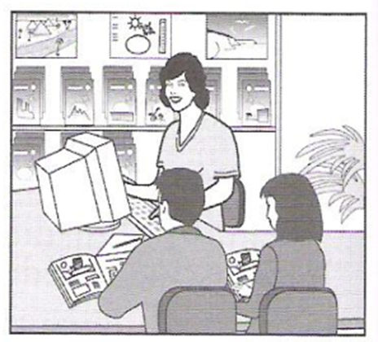
- What has the daughter forgotten to bring on holiday?  Dầu gội đầu | 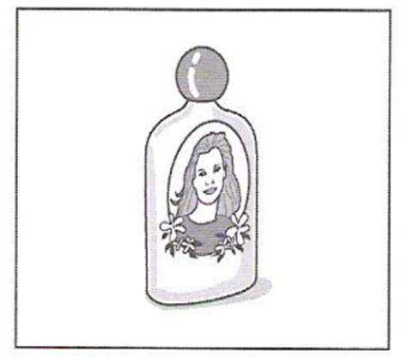
- What will the man and woman do on Sunday?  Trên bãi biển | 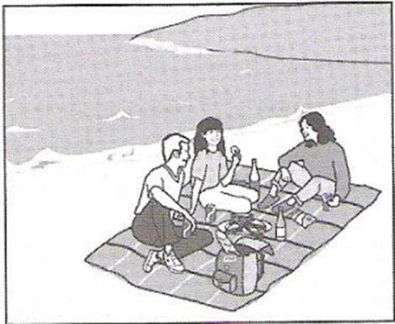
- Which blouse does the girl decide to buy?  Áo có cổ, dài tay | 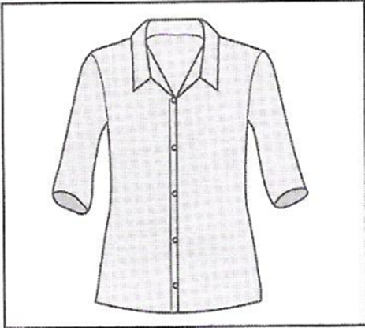
- When is the girl having a party?  Ngày 13 | 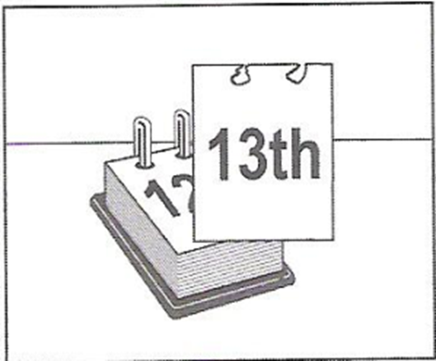
- Where is the motorcycle race going to finish?  Quảng trường | 
- What will the woman repair next?  Bóng xì hơi | 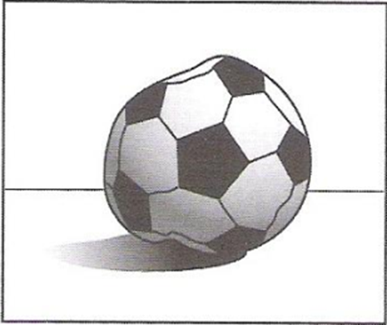
- What has the boy lost?  Máy ảnh | 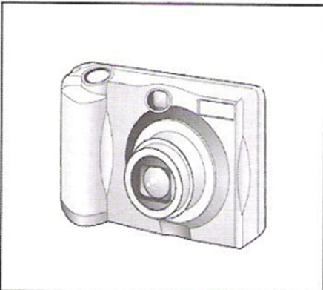
- What time does the race begin?  2h30 chiều | 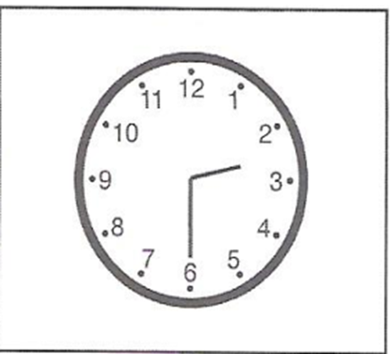
- Which musical instrument does the boy play now?  Bộ trống | 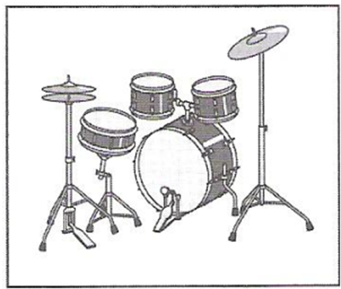
- What will the weather be like tomorrow afternoon?  Mây mưa | 
- What is the subject of James Wilson’s book?  Sách về máy tính | 
- Which part of the man’s body hurts him at the moment?  Đau vai | 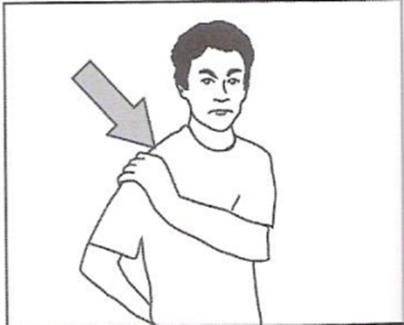
- Where was the man’s knowledge of Spanish useful?  Cửa hàng quần áo | 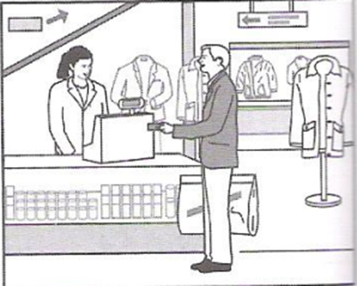
- Which present will the girl receive?  Cái thảm | 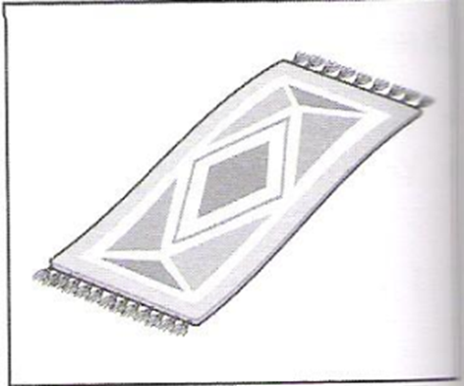
- Where will the tourists go last?  Du thuyền | 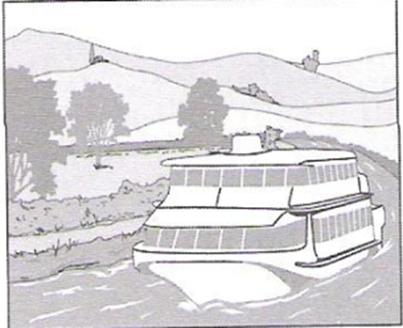
- How much does the man pay for the postage?  Tem 18.5 euro | 
- Where in the theatre did the woman leave her gloves?  Các hàng ghế | 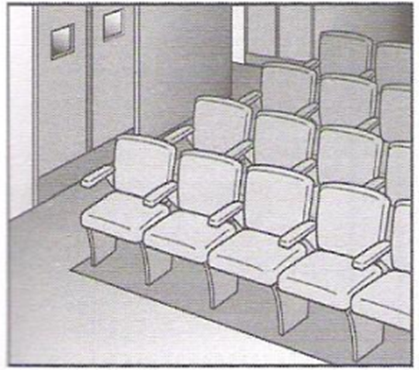
- Which dress does the woman like best?  Váy chấm bi | 
- What is the television programme about?  3 com chim cánh cụt | 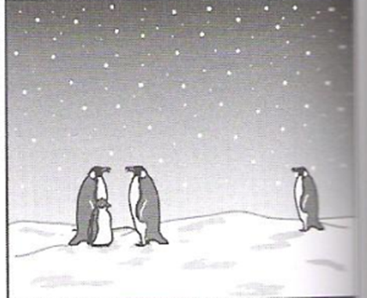
- Which vehicle does Steve intend to buy?  Ô tô 7 chỗ | 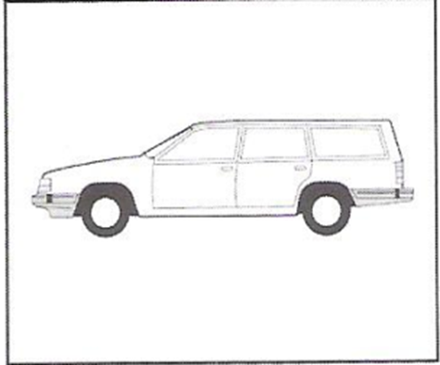
- Which prize has the man just won?  Bát thủy tinh | 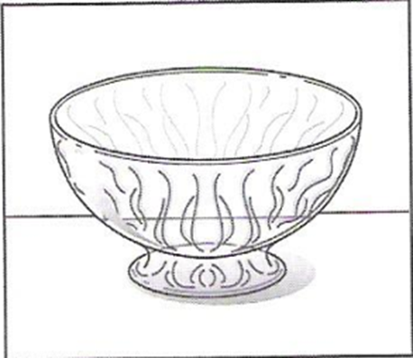
- What was the man’s first job?  Lau kính | 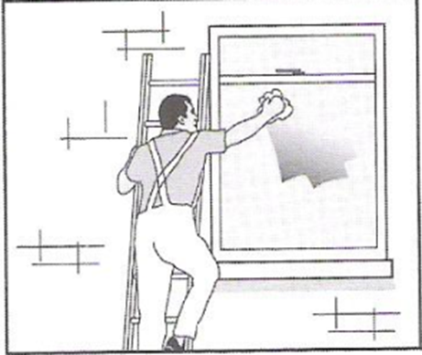
- Where will they have something to eat?  Trong nhà hàng | 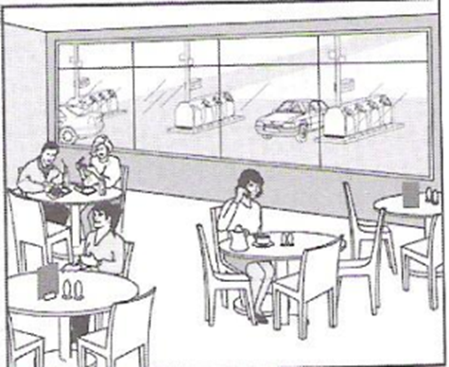
- What does the woman’s house look like now?  Có chỗ để ô tô, không có cây | 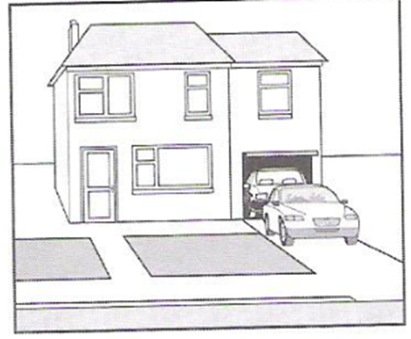
- Which sport will they do tomorrow?  Cưỡi ngựa | 
- What can you see on the television programme?  Trái đất | 
- Where will the man sit on the plane?  Hàng ghế sát lối đi | 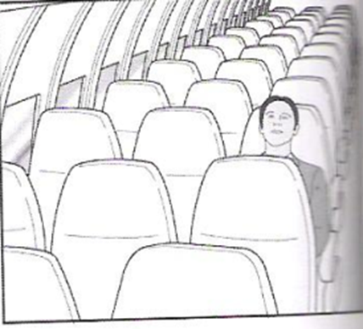
- What did the man buy? | 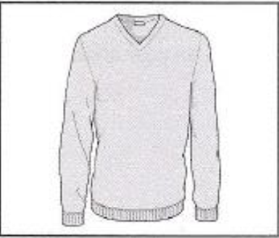
- How will the woman help the man? | 
- What will the students buy for their teacher? | 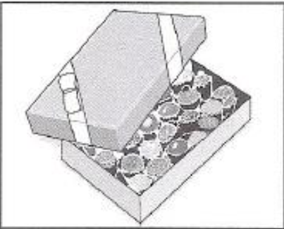
- Which exhibition is the busiest today? | 
- Where can visitors see the ducks? | 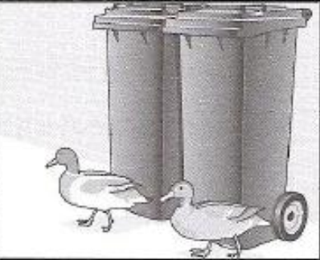
- What will the weather be like when the festival starts? | 
- What has the man sent back to the company? | 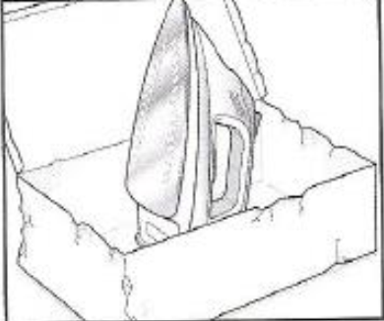
- Which part of the Arts Centre only opened recently? | 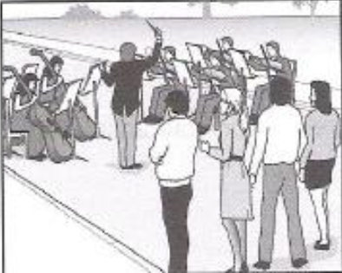
- What does the shop assistant give the man? | 
- Where does the woman feel pain? | 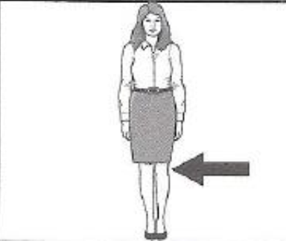
- Where must the woman go to buy dollars? | 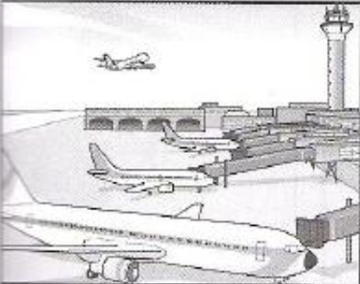
- Which vegetable is used in all today’s recipes? | 
- Where is the meeting? | 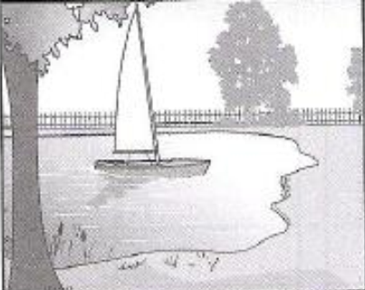
- How did the man want to pay? | 
- How are they going to get to the cafe? | 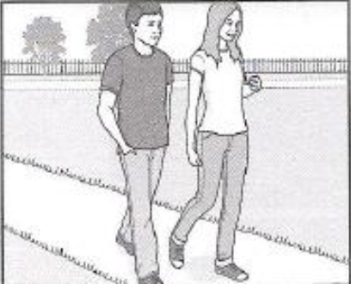
- What has the man had a problem with? | 
- When does the man plan to get up? | 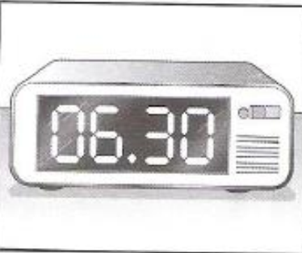
- What are they going to order? | 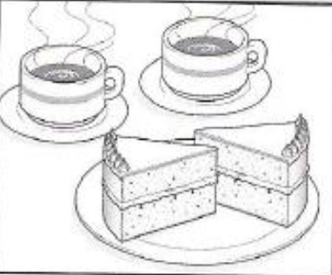
- What is the woman phoning about? | 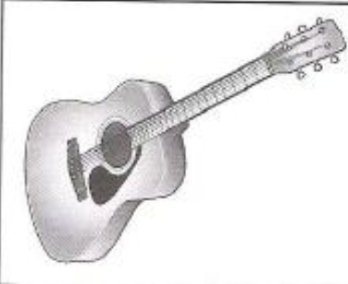
- What are they going to watch first? | 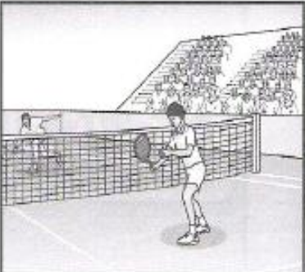
- What is the woman going to buy?  2 áo trắng | 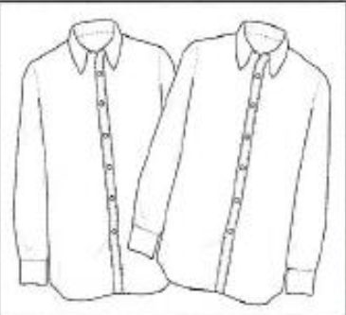
- Where will Peter give Joanna the book? | 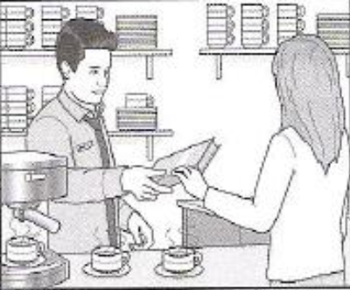
- What did the girl buy at the market? | 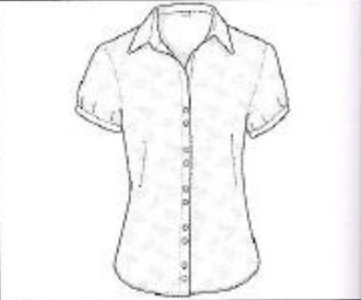
- What will the weather be like for the race? | 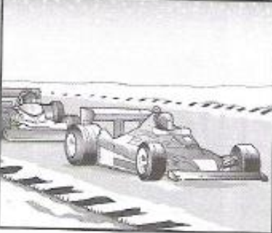
- What dees the girl like best about the city? | 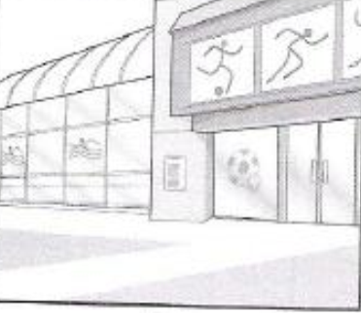
- What does the boy think was unusual about the film? | 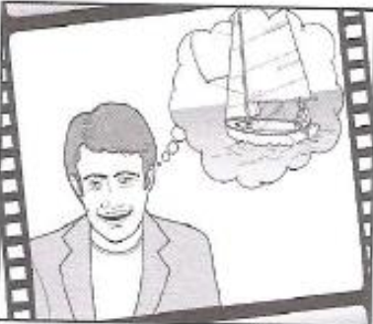
- What happened during the football match? | 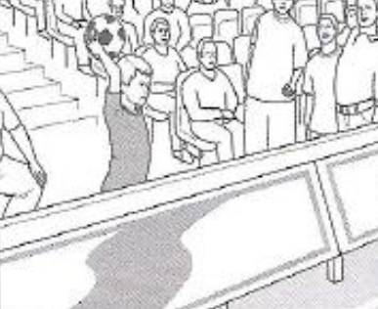
- Which part of the gallery did the man visit? | 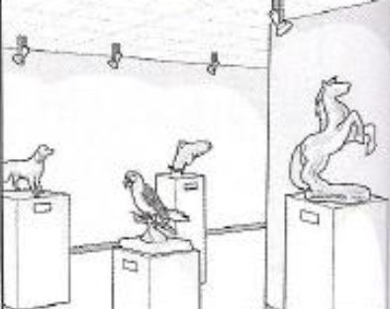
- What did the man do at the sports centre yesterday? | 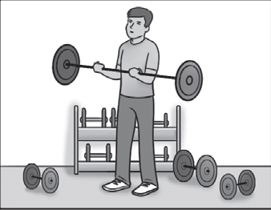
- Which sport does the woman compete in? | 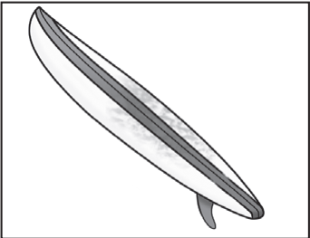
- Where will the friends go running this evening? | 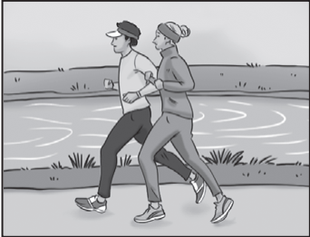
- Which winter sport was Max good at when he was young? | 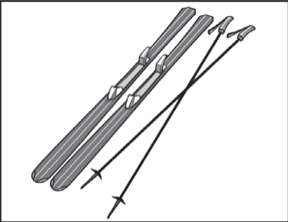
- What did the girl lose? | 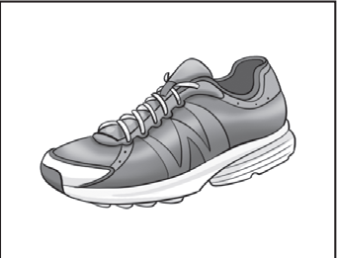
- Which sports instructor is the man going to meet today? | 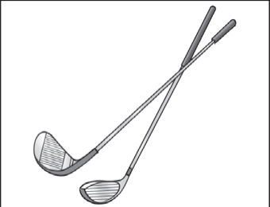
- What will open at the sports centre soon? | 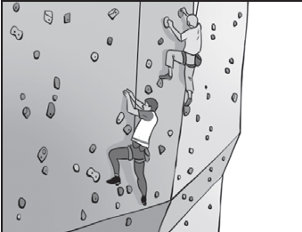
- What time will the flight to Brussels leave? | 
- What does the man enjoy most about flying? | 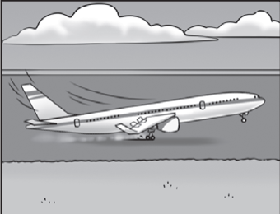
- Where will Maggie’s family stay on holiday this year? | 
- What has the woman left behind? | 
- What will be weather be like when the plane arrives? | 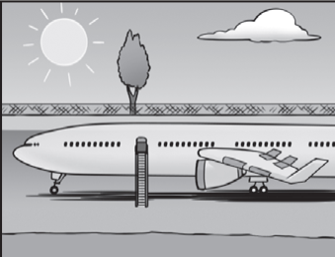
- What was damaged during the journey? | 
- Where can you park your car for free? | 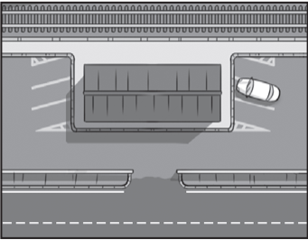
- Which is the girl’s favourite photo? | 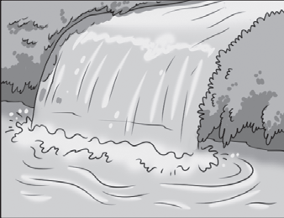
- What should people not do? | 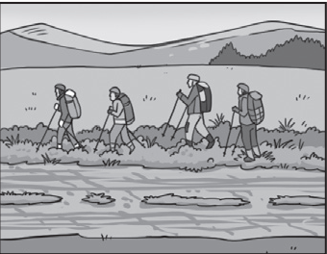
- What has the woman studied in college this week? | 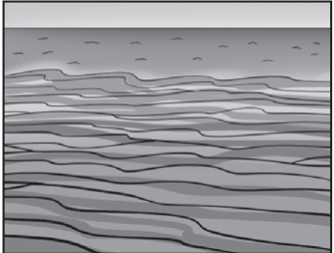
- Where does the man prefer to swim? | 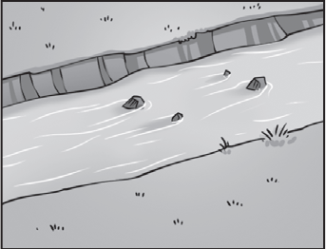
- What did the students enjoy learning about in the lecture today? | 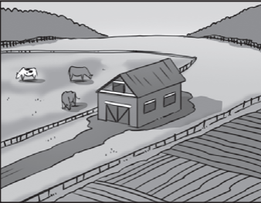
- How did the family travel in Iceland? | 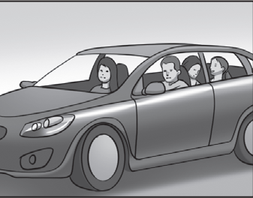
- What did the friends learn about in the TV programme? | 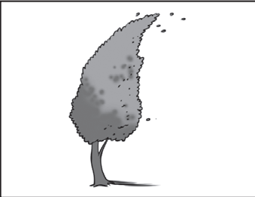

Part 2
1. What was Robin’s job in Argentina?
C. travelling salesman
2. On Robin’s last trip to Argentina, the weather was
B. suitable for what he planned.
3. What did Robin buy from the market he visited?
A. a picture
4. How did Robin feel during the dance performance he saw?
A. He wanted to get up and dance.
5. What did Robin do while he stayed in the village?
C. He went on a river trip.
6. What did Robin like about his favourite place?
C. the peace
1. Harry first became interested in adventure travel because his father
C. talked a lot about the places he’d been to.
2. Harry decided to start an adventure travel company because he
A. wanted to share his experience with others.
3. Who suggested the name for Harry’s company?
B. a customer
4. When Harry visits a place, he tries to
C. avoid damaging the area.
5. What does Harry say about doing dangerous things?
A. It’s part of his job.
6. What is Harry’s favourite place?
B. a building

1. Linda worked in a cake shop because
A. her parents didn’t give her enough money.
2. Linda liked her first boss because he
B. was kind to her.
3. What did Linda enjoy about working in the shop?
B. the smell of baking
4. In the shop, Linda helped with
C. making sandwiches
5. Linda says that the full-time shop assistants
B. hadn’t got the same skills as her.
6. What does Linda say about serving customers?
C. She enjoyed the busy part of the day.
1. What does Lucy usually paint?
A. scenery for stage plays
2. Lucy chose her present job because
C. she thought it would be interesting.
3. What does Lucy find difficult about her work?
B. Some days are too busy.
4. How many hours a day does Lucy usually work?
C. eleven
5. How does Lucy travel to work?
C. By public transport
6. What does Lucy do in her free time nowadays?
A. She studies.
1. What does Tim enjoy most about his job?
C. listening to lots of good music
2. Young musicians who want to do the course
A. need to fill in an online form.
3. Tim says that the teachers on the course
A. usually enjoy themselves.
4. Tim likes to hold the course in a place which
B. is convenient for public transport.
5. What does Tim say about musical instruments?
C. Students keep them in a special place.
6. What does Tim say about the concert tour after the course?
B. It needs to be carefully planned.

1. What did Marta dislike about her first job?
B. The boss didn’t listen to her.
2. At first, what did Marta find most surprising about mobile restaurants?
A. They are only advertised online.
3. For Marta, the best thing about mobile restaurants was
C. finding that waiters weren't needed.
4. Marta had difficulty serving food on a beach because of
C. the wind.
5. Marta tries to avoid serving meals in her home because
C. there is a lack of space.
6. What worries Marta about the future?
B. the wrong people opening restaurants like hers
1. Why did Jack take photographs of street signs?
B. The colours were exciting.
2. Why did Jack go into his yard to take his winning photo?
C. He was trying out some new equipment.
3. When Jack first looked at his winning photo, he felt
C. unsure how clear the detail was.
4. Jack was surprised by the other photos in the competition because
A. the quality was so high.
5. Since winning the competition, Jack now hopes to
B. travel to different countries.
6. Jack advises other young people interested in photography to
A. have the same attitude as him.
1. Amy decided to become a fashion designer while
B. she was working in a shop.
2. Amy says the most important skill for a designer is
C. understanding how clothes are made.
3. What does Amy particularly like about her work?
C. having her name recognized
4. How does Amy feel about today’s fashion?
B. She feels clothes should be more attractive.
5. What helps Amy find new ideas for designs?
A. seeing things around her.
6. What project is Amy working on at the moment?
A. a collection of clothes for a film

1. Brittany realized that she really enjoyed acting when.
C. She took part in a school play
2. How did Brittany feel before her first theatre performance?
B. Anxious that she would use the wrong accent
3. Why did Brittany move into TV acting?
C. She wanted to try something new
4. What does Brittany still find difficult about screen acting?
B. Learning to speak more quietly
5. Brittany particularly enjoys
A. Receiving a new part to learn
6. What does Brittany dislike about being an actor
C. Starting work early in the morning
- Why did Carla change the way she worked?
B. She spent very little time at home.
- What does Carla say about running her own business?
A. She continues to work a lot of hours.
- What changes did Carla make to her exercise routine?
C. She exercises at a different time of day.
- How does Carla feel about her health and eating habits?
C. surprised that she now feels so much better
- Where does Carla spent time with her sister?
A. in her own home
- Which time-saving idea does Carla find efficient?
B. having a lot of similar clothes
- What does Scott say about his ‘capsule’ apartment in Japan?
C. He had to think carefully about where to put things.
- Scott says that the ‘upside-down’ house he lived in
A. wasn’t as exciting as he thought it would be.
- How did Scott feel when he had to leave his home in London?
B. pleased to escape the effects of the weather
- What does Scott enjoy about living in cities?
C. seeing lots of people
- What problem has Scott had with his water building?
A. It’s hard to find the right colour for it
- Why would Scott like to design a railway station?
B. to test his design skills

Part 3:
FILM AT THE SCIENCE MUSEUM
The Film Country it is about: Greenland
Day it is on: Sunday
Time last performance starts: 5 o’clock
Other things to do at the museum
— use the computer in the basement
- see a model space - ship on the first floor
- try the cafe on the top floor
How to get free tickets for the film
— send an email before 12 o’clock on Friday
STUDY PROGRAMME
Courses available on: ■ English Literature
■ 18th century artists
■ Modern Architecture
Dates for all courses: ■ start date: 14th June
■ end date: 12th July
■ classes: every day except Fridays
Course fees: £425 each
Reduced prices for groups
Included in price: ■ accommodation and food
■ use of the library
■ social activities
■ books
Not included in price: ■ extra lessons
■ transport
Available from college secretary: ■ registration forms
■ a copy of the timetable for your course

Central Museum
The museum gardens were first created in the year 1921
There are exhibitions of English furniture and Japanese art.
In the museum shop, visitors can buy gifts, cards and books.
Cars can be parked at the hotel near the museum.
Regular buses to the museum leave from both the city centre and the rail station
Call 451858 to find out more about groups visits or room hire.
NEW MAGAZINE
The name of the magazine is good living
First issue of magazine
• healthy recipes using fish
• a DVD about making salads for summer
Second issue of magazine
• recipes using rices for children
• special recipes to use for party for adults
The first issue of the magazine costs £ 2.49
Desert Train Trip
The time the trip takes is one hour
In the past, Oldsville had an important oil industry.
Passengers can see pretty plants close to the train.
There are some attractive rocks to see under an old bridge.
In a small store on the train, souvenirs are on sale.
Today, refreshments will be for sale in a basket machine.
instead of from a
Outdoor cinema
The cinema is surrounded by hills and there are beautiful views.
It's possible to watch the sunset during a film.
Cinema visitors are advised to take a cushion with them to sit on.
The cinema is 5 kilometres from the city if you go on
foot.
It's a good idea to have a picnic when the film is over.
Cinema tickets can be bought online at www.cityents.org.
STUDENT RUNNING CLUB
The club meets at the football stadium in the town.
Last year’s members will be sent a registration form by email
Members v/ho pay $5 receive a special sports bag that shows the club’s name.
All runners will get a water bottle as a free gift.
You know the runner's level of experience by the colour of their shirt
Contact Carol beaton on 8302195.
Working in a forest in New Zealand
Steve had accommodation in a shared tent
Steve says it was important to have good meals at the end of each day.
Steve worked with a team that made a path through the forest.
Steve also collected information needed fora map of the forest area.
In the morning Steve was surprised to Fear the sound of rabbits in the forest.
When he did the trip, Steve only had to pay for his flight
The film review programme
This week’s reviews
The film Jungle Fever is a cartoon about a family of tigers.
Actor Steve Wills plays a chef in his new film, Call it.
Swim is about a man who wants to swim in a local lake.
Competition for listeners
Listeners an enter an online quiz at www movies . co.
Winner will receive restaurant Tickers.
Entries must be received on January 28th by 2pm.
Training session for new sales assistants

The training manager is called Mandy Hickets.
New assistants will work on the ground floor.
Part-time workers have a rest day on Thursday every week.
Workers who live in the town can use the store’s bus service for free.
The staff discount cannot be used to buy food .
Assistants need to collect their ID card on their first day.

Extreme Bootcamp

The army use the name ‘bootcamp’ for soldiers’ training.
Extreme Bootcamp takes place on a bridge so you can exercise and look at the river. Members start each class at 6.30 am by doing some jogging.
Wear the same clothes as for other exercise classes, and bring good trainers.
The next bootcamp starts on 30th September.
Contact Ellie shawes for more information.

- Natasha has decided to take the day off work to go running. No
Part 4
- Colin found running to work was bad for his health. Yes
- Natasha would prefer to go running outside the city. Yes
- Natasha would like to wear her sports clothes at work. No
- Natasha will run in the big race because she hopes to win it. No
- Colin and Natasha will prepare for the big race together. No
- Claire has read about the football tour in a newspaper. No
- Claire is worried about being the youngest member of the team. No
- Tom feels that schoolwork is more important than sports training. Yes
- Claire intends to study at a university next year. No
- Claire thinks it’s important to win every game on the tour. No
- Tom agrees to go and support Claire’s team at her next match. Yes
- Carla is surprised that Mrs Ford wanted her to attend the meeting. No
- Sam says that last year’s concert was an improvement on earlier ones. Yes
- Carla enjoyed preparing for last year’s concert. No
- Sam tells Carla that she is the best pianist in the school. No
- Sam encourages Carla to accept Mrs Ford’s choice of music. No
- Sam realises that he must stop doing one of his activities. Yes
- Jenny and Karl are both pleased to be home after their holiday. No
- Jenny thinks the weather forecast they heard for their holiday week was correct. Yes
- Jenny and Karl both liked the way their hotel served meals. Yes
- Jenny thinks they had a better room on this holiday than last year. No
- Karl was angry about the state of the hotel sports equipment. No
- Jenny and Karl are both keen to plan another holiday immediately. No
- They agree that the wildlife centre building is well designed. No
- Julie thought the sharks at the wildlife centre were frightening. No
- Julie found the building was too warm. Yes
- Greg was disappointed with the number of insects. Yes
- Greg only managed to see one tree frog. No
- Julie is very keen to return to the wildlife centre. Yes

- Karl says it’s been difficult finding somewhere to live. No
- Karl has had problems studying in anotner language. No
- Laura is surprised at how little work there is on her course. No
- Karl is uncertain whether to return home after his course. Yes
- Laura is missing her parents. Yes
- Laura feels that she’s too busy to visit Karl. Yes
- Peter wants to take his sister to the party. No
- Anne hopes the party will be bigger than the one last year. No
- Peter thinks the new college hall is big enough for the party. Yes
- Peter thinks DJs play a good range of music. No
- Anne hopes the college cafeteria will supply the food for the party. No
- Peter is confident the party will end after midnight. Yes
- They agree that the last show in the series was complicated Yes
- James believes that the series is successful because of the main character. Yes
- They both admire the main character’s behaviour. No
- Martha thinks that the main character has similar skills to a detective. Yes
- James was surprised to find the main character so funny. No
- They both plan to watch the series again. No
- Robin is surprised by how much recycling people do in his town. Yes
- Lisa think it takes too long to recycle metal. Yes
- Robin believers there should be more bottle banks. No
- Lisa thnks that people are making good progress with paper recycling. Yes
- Robin and Lisa agree that people need more information about plastic. No
- Robin thinks that people should pay less to use public transport. Yes
- Ted thinks he wastes time looking at Instagram. No
- Ted is surprised at how long Sylvia spends online every day. No
- Sylvia admits that she finds it difficult to sleep after looking at screens. Yes
- Ted and Sylvia agree that Snapchat is fun to use. Yes
- Sylvia thinks that some people use Facebook in the wrong way. Yes
- Ted and S both enjoying reading posts on Twitter. No

- Sophia thinks that Japanese is a difficult language to learn. Yes
- Aaron and Sophia agree that it is important to learn languages. No
- Aaron thinks he has a natural ability for remembering new words. Yes
- Sophia feels worried when she can’t understand what someone says. No
- Aaron thinks writing is the most difficult skill. Yes
- Both Aaron and Sophia think it is useful to make mistakes. Yes

